Felipe Ehrenberg – Please Read Carefully – Somers Gallery

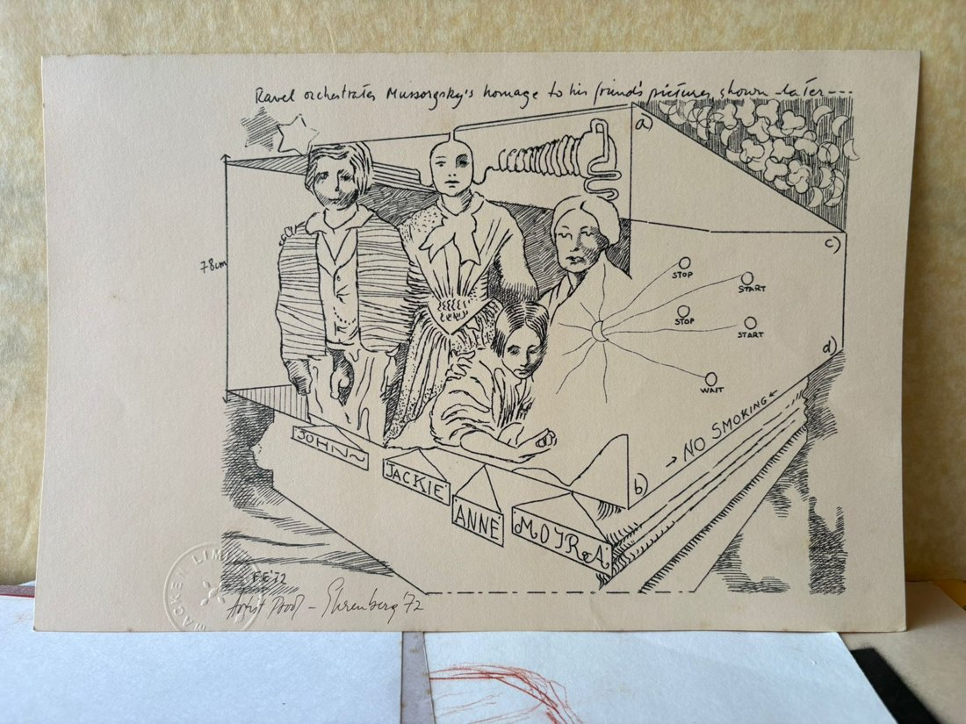 | John, Jackie, Anne, Moyra  Medium: mimeograph print on yellow paper with watermark  Year: 1972  Price: $320
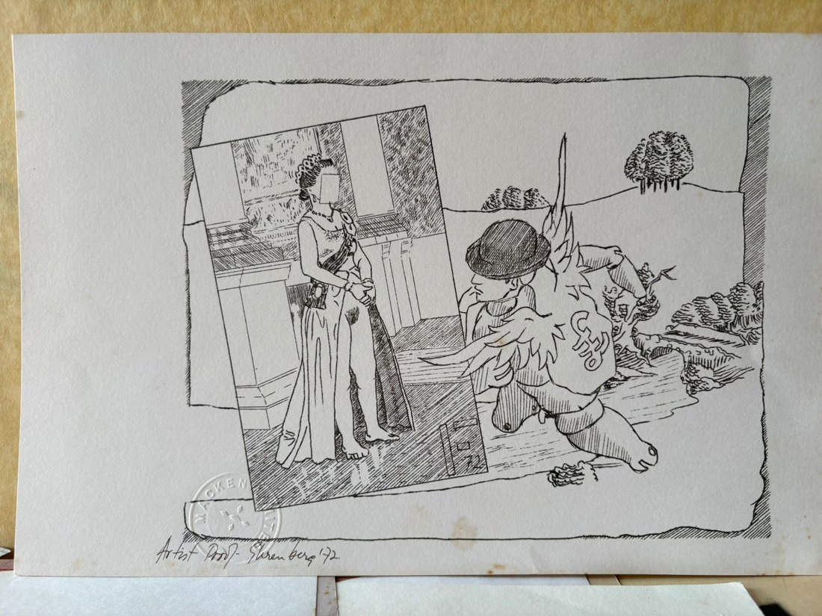 | Reina  Medium: mimeograph print on ivory paper with watermark  Year: 1972  Price: $320
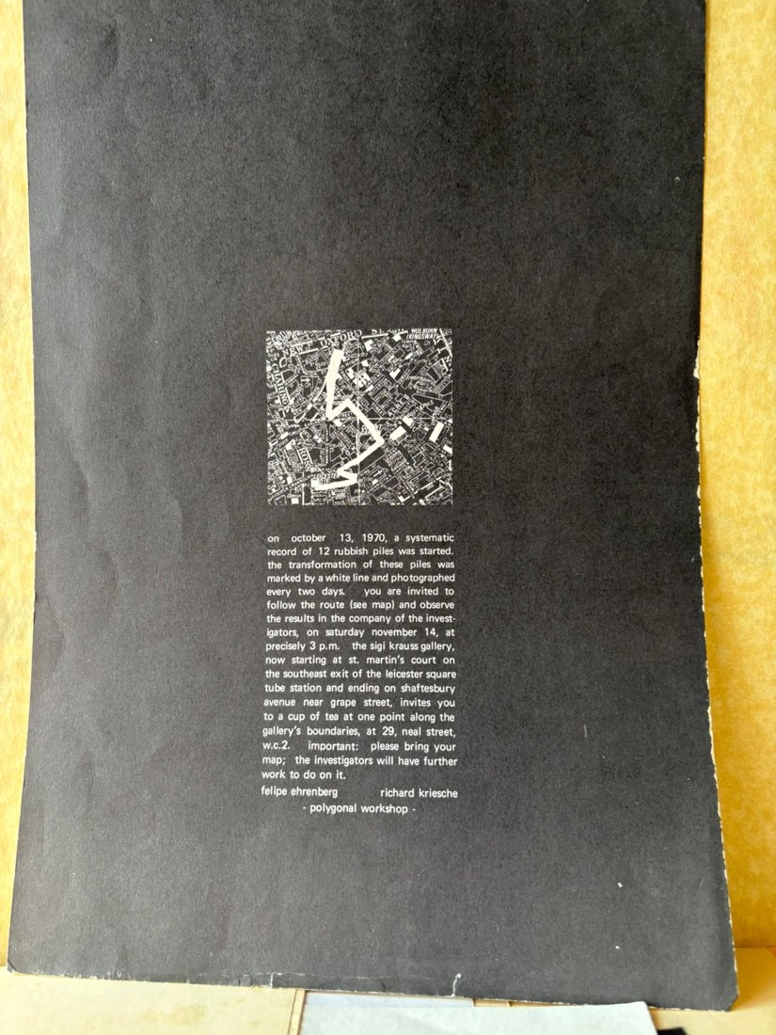 | Polygonal Workshop  Medium: print on black card  Year: 1970  Price: $75
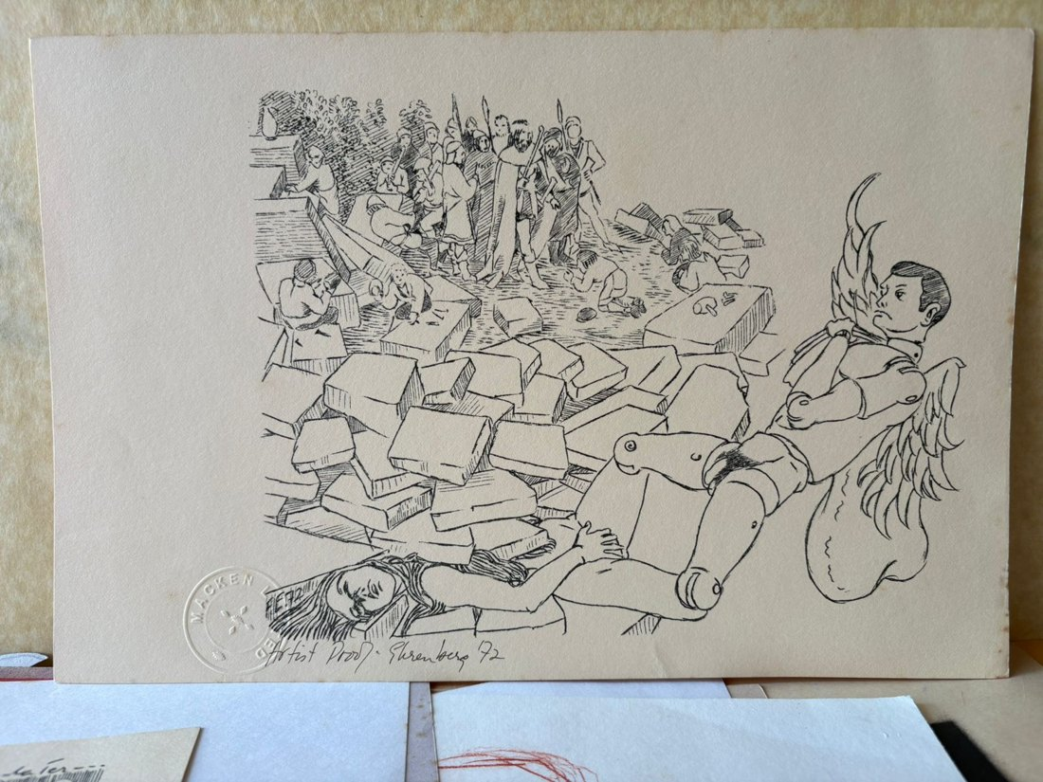 | Ángel caído  Medium: mimeograph print on yellow paper with watermark  Year: 1972  Price: $320
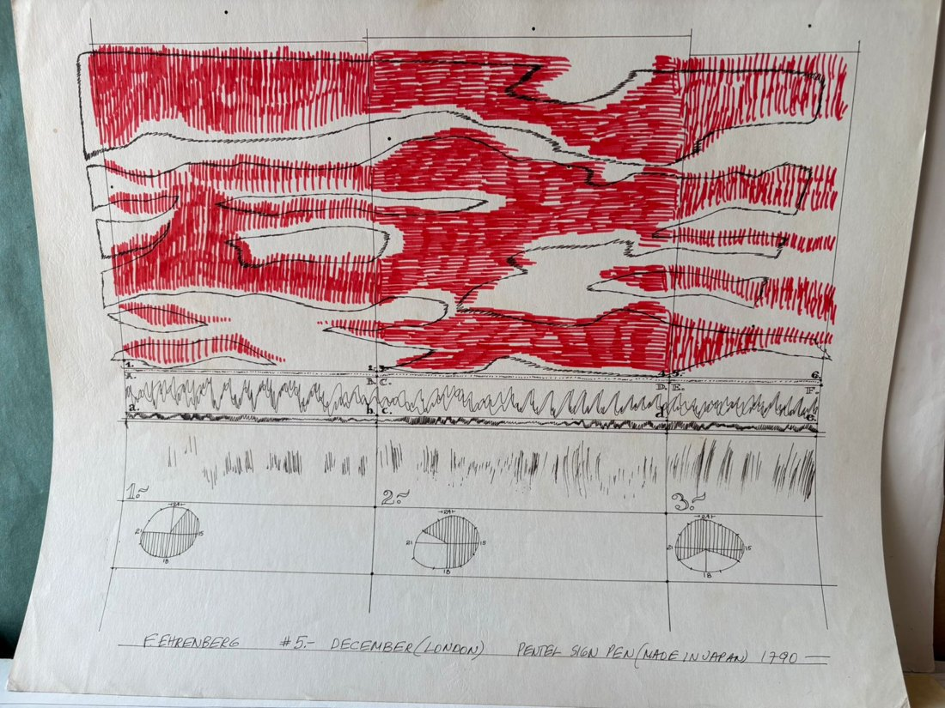 | Pentel Sign Pen (made in Japan)  Medium: pen and coloured marker  Year: 1970 (1790)  Price: $1,800
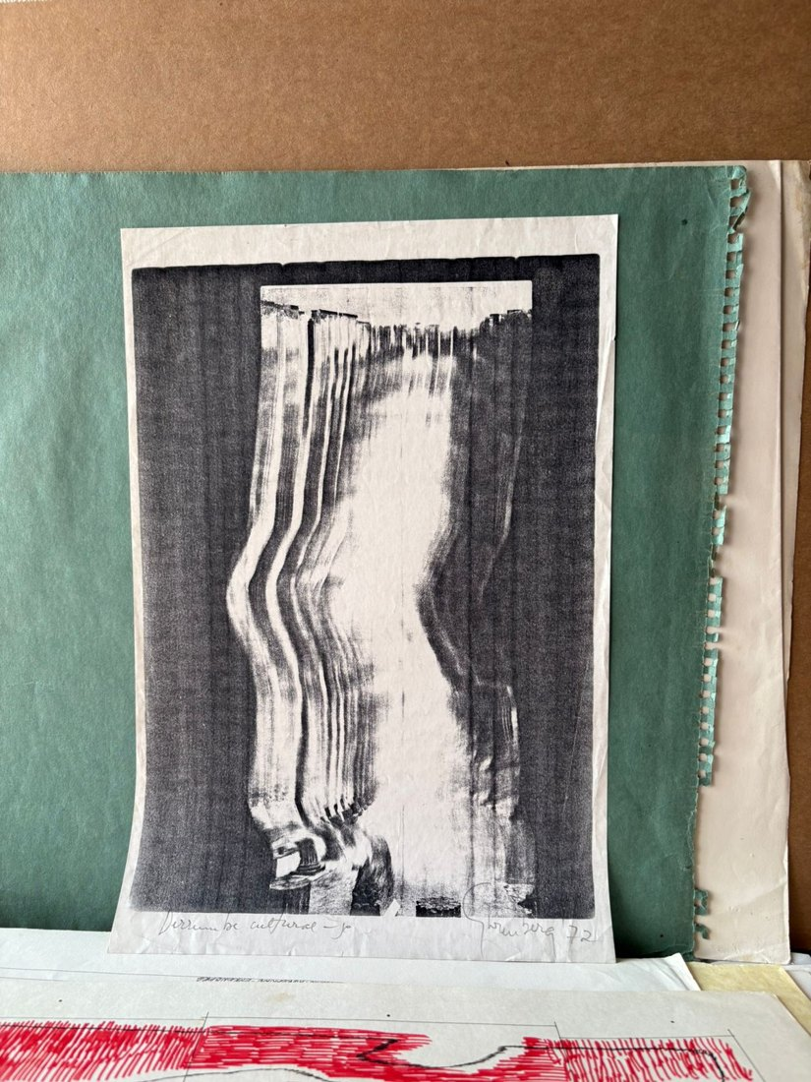 | Derrumbe Cultural  Medium: mimeograph  Year: 1972  Price: $350
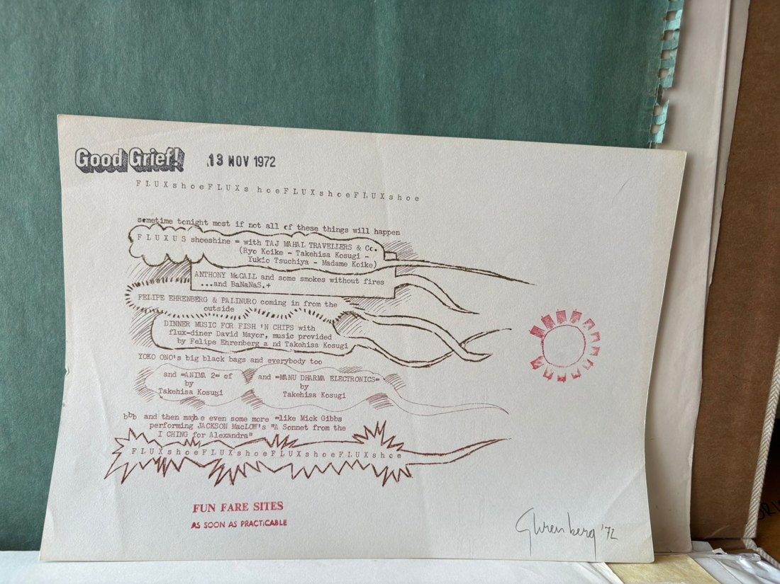 | Fluxshoes  Medium: mimeograph print in different inks  Year: 1972  Price: $50
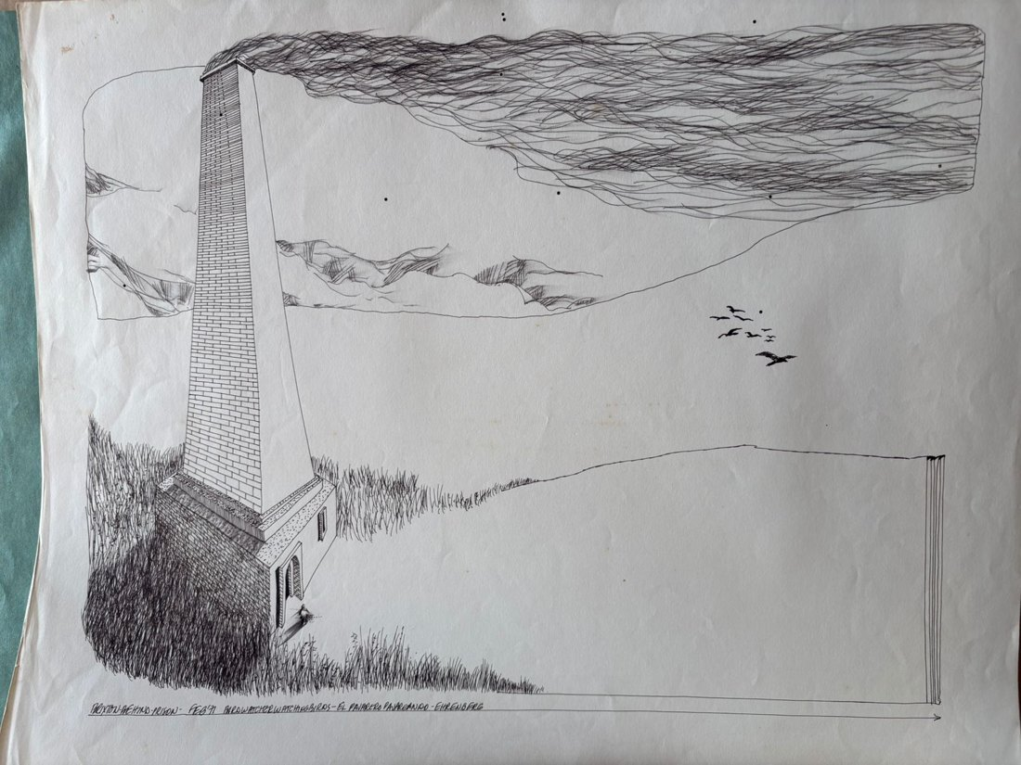 | Brixton – Behind-Prison  Medium: pencil and ink on paper  Year: 1971  Price: $1,500
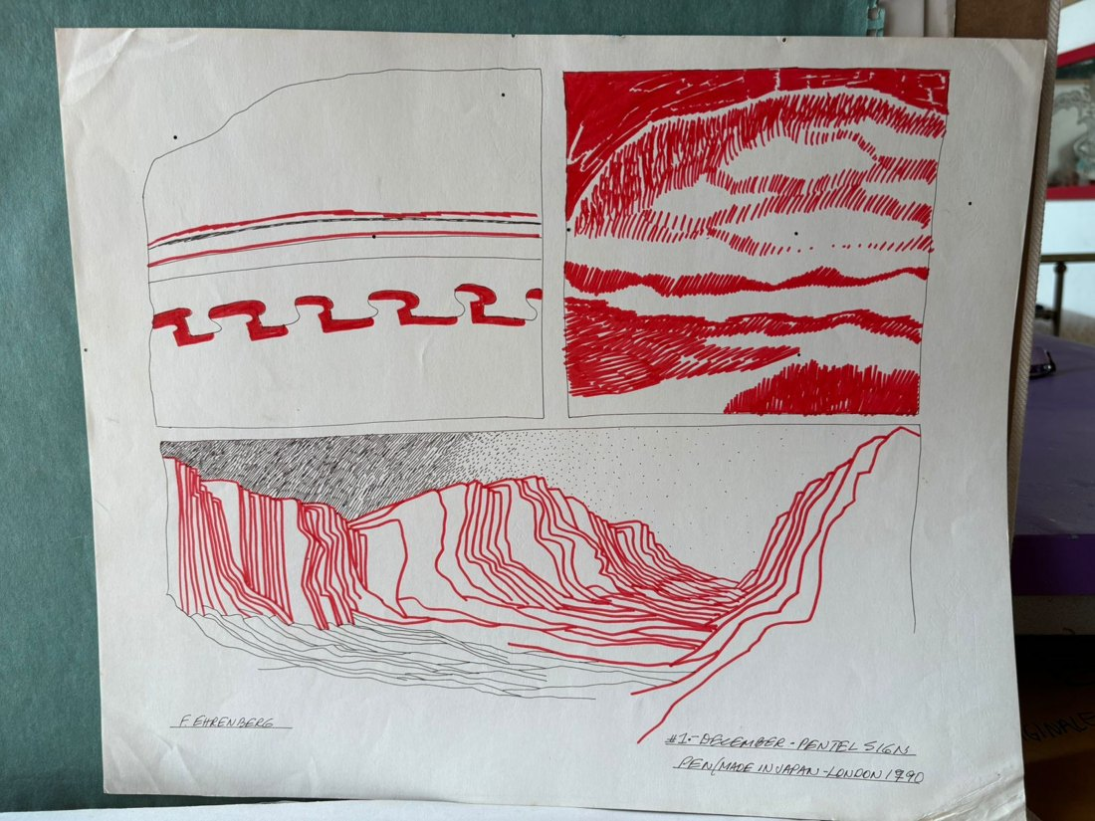 | December - Pentel Sign #1  Medium: ink and coloured marker  Year: 1790 (1970)  Price: $1,800
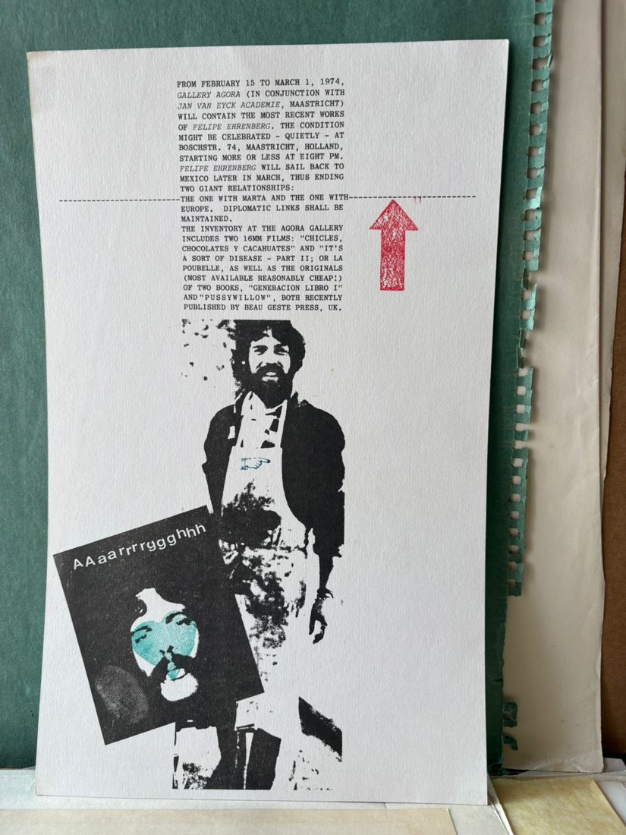 | AAaarrrrggghhh  Medium: mimeograph print, intervened with coloured stamps on both sides  Year: 1974 – double-sided  Price: $250
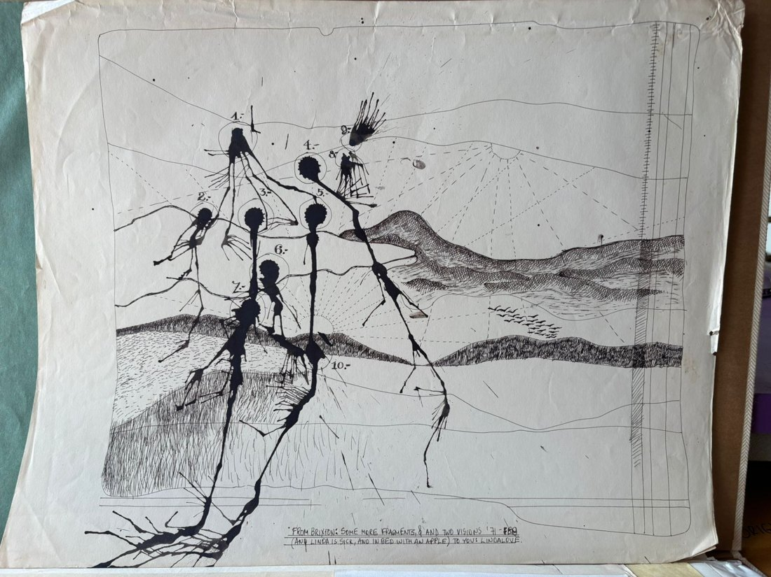 | From Brixton  Medium: pen and ink on paper  Year: 1971  Price: $1,000
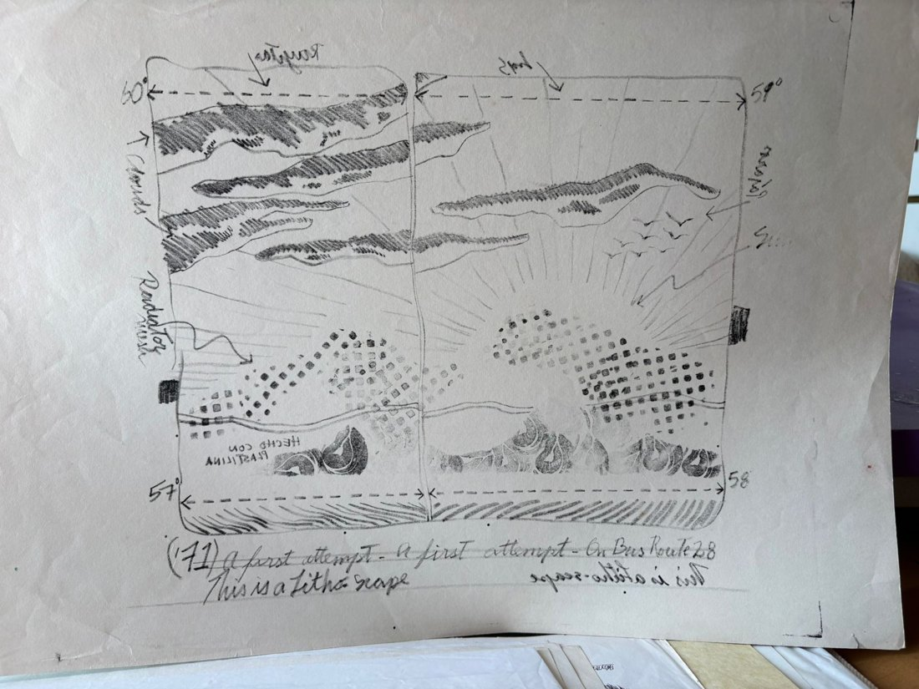 | A first attempt – On Bus Route 28  Medium: single-colour print with plasticine stamps  Year: 1971  Price: $850
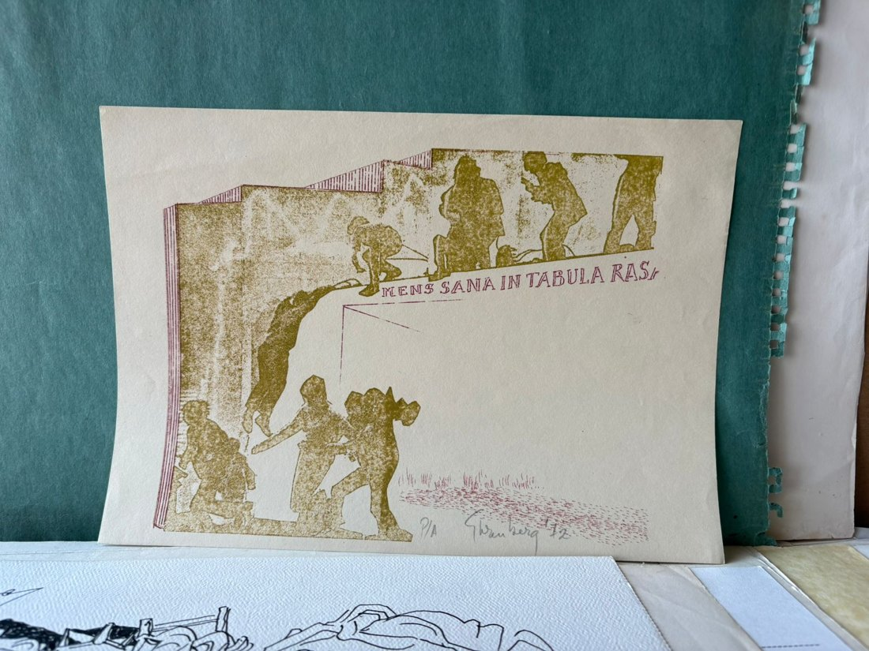 | Mens Sana in Tabula Rasa  Medium: mimeograph print in two inks  Year: 1972, A/P  Price: $320
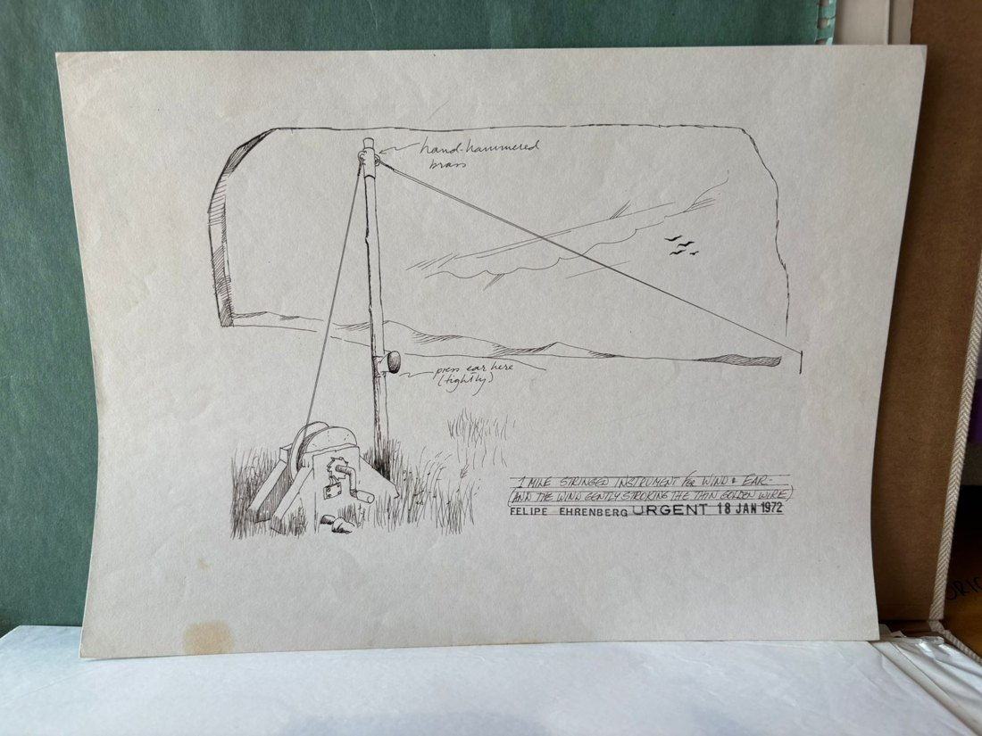 | 1 Mile Strings Instrument  Medium: ink and rubber stamps  Year: 1972  Price: $1,000
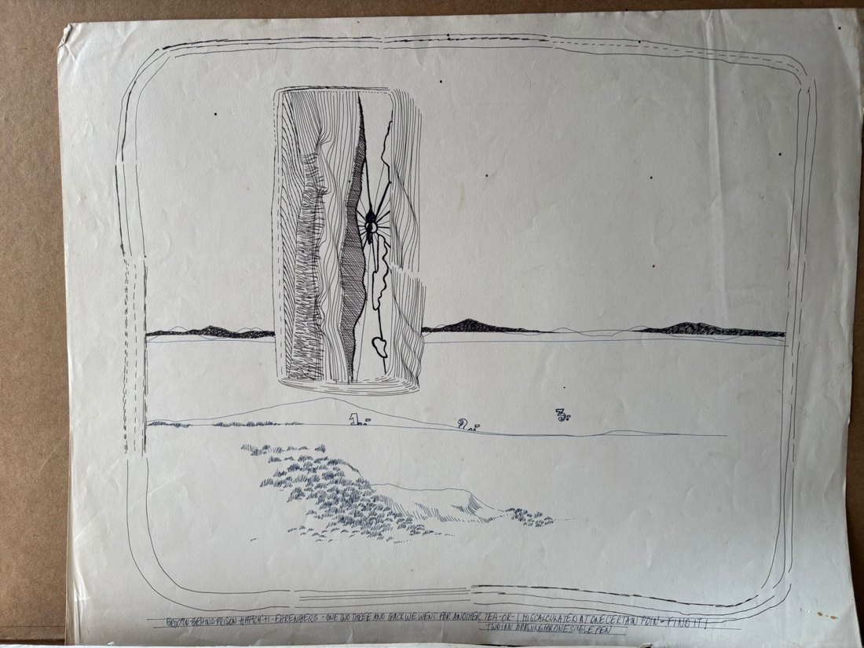 | 1-2-3  Medium: pen and marker, 2 colours  Year: 1971  Price: $1,000 / $1,200
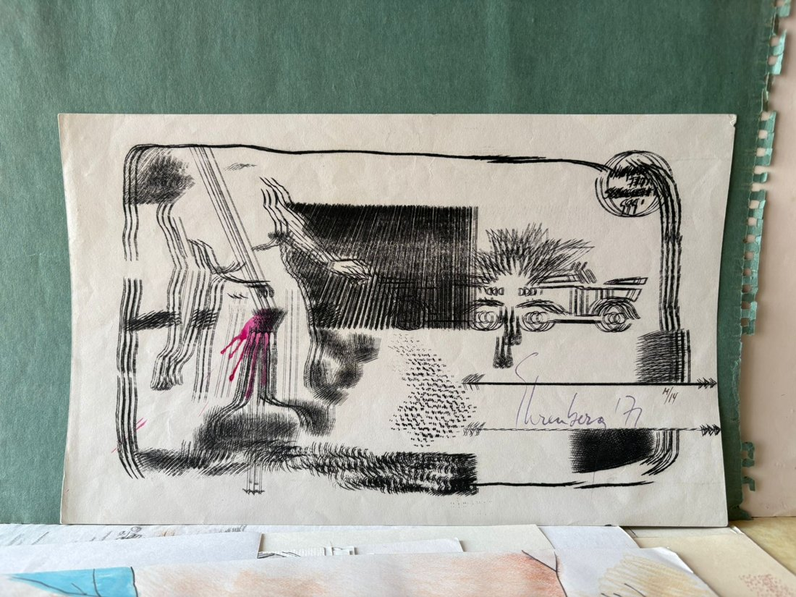 | Borroso  Medium: mimeograph print in two inks  Year: 1971, 14/14  Price: $320
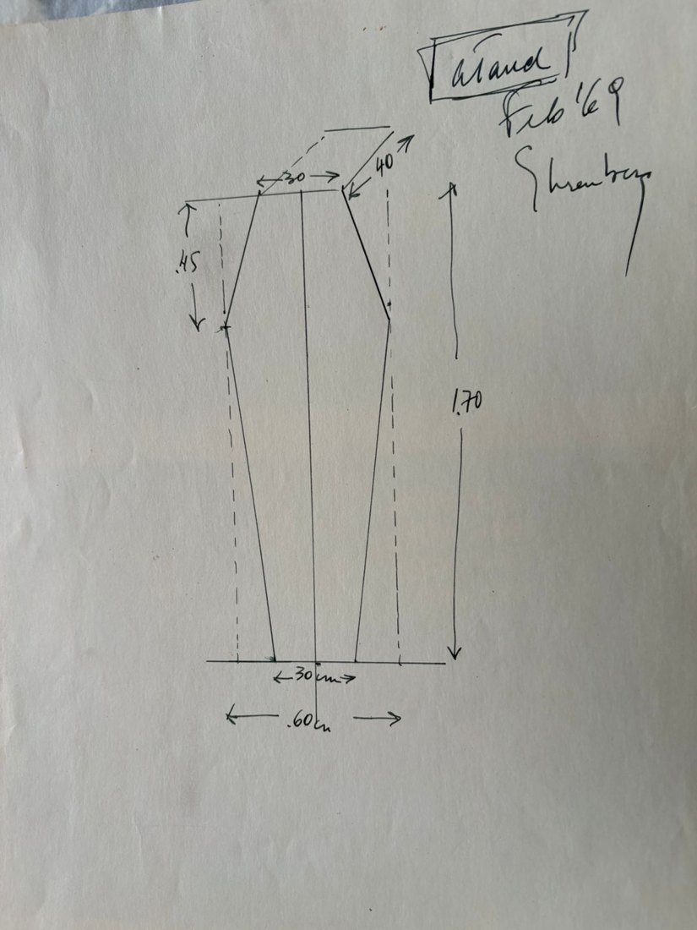 | Ataúd  Medium: ink drawing  Year: 1969  Price: $320
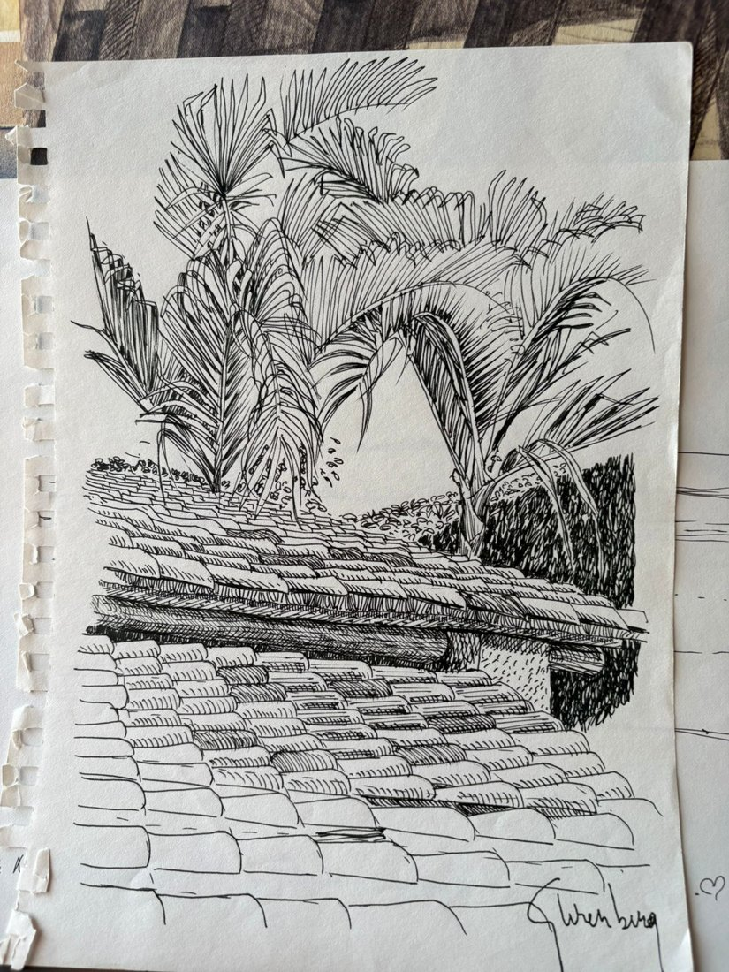 | Techo  Medium: India ink drawing  Year: 2003-2004  Price: $500
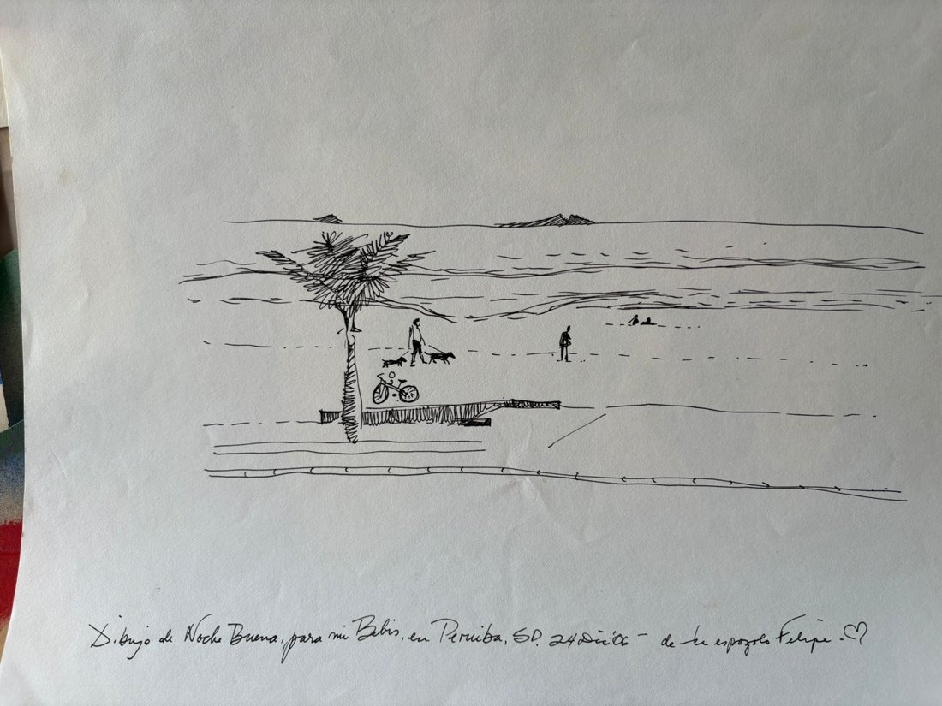 | Dibujo de Noche Buena  Medium: India ink drawing  Year: 2006  Price: $500
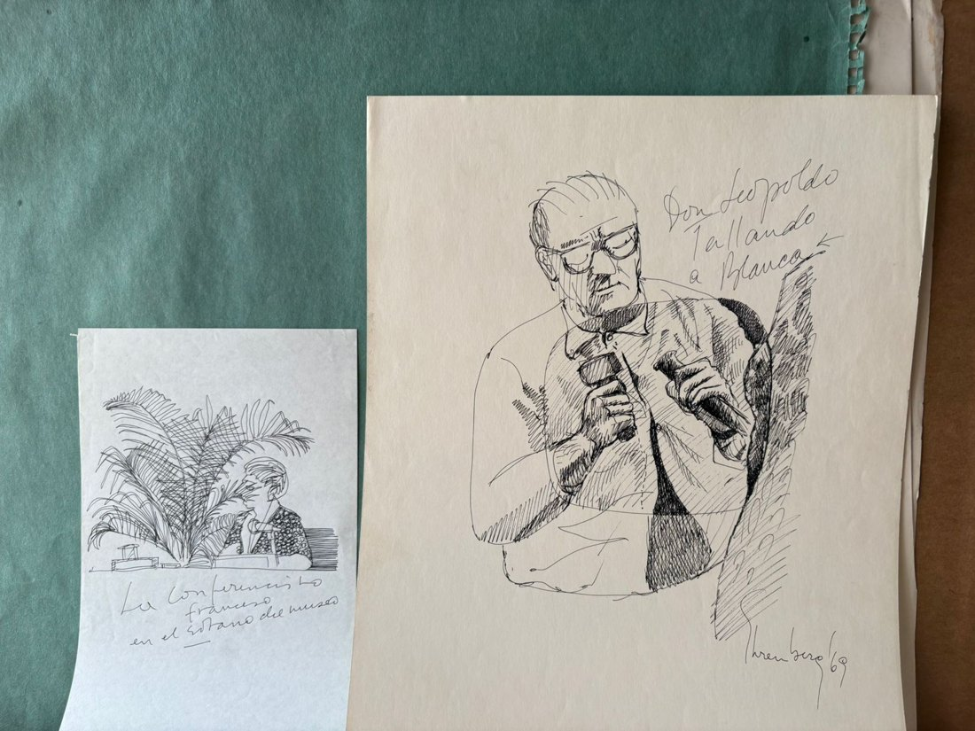 | La conferencia francesa en el sótano del museo  Medium: ink on paper  Year: c. 1980s  Price: $80
Don Leopoldo tallando a Blanca
Medium: ink on paper
Year: 1969
Price: $600
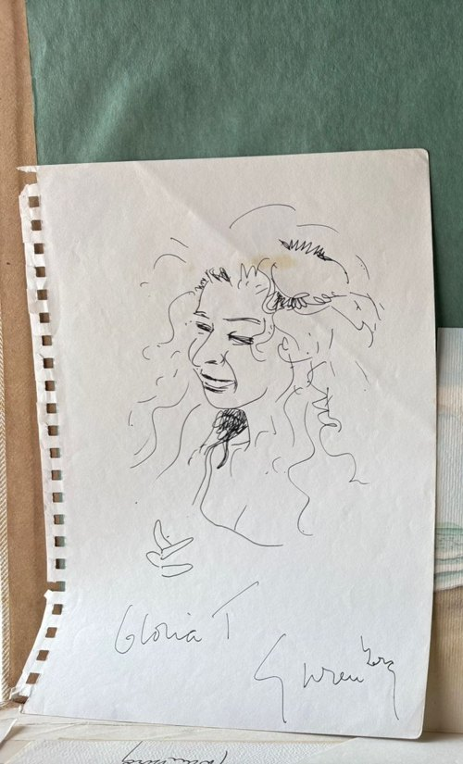 | Gloria T.  Medium: India ink on paper  Year: 1996  Price: $300
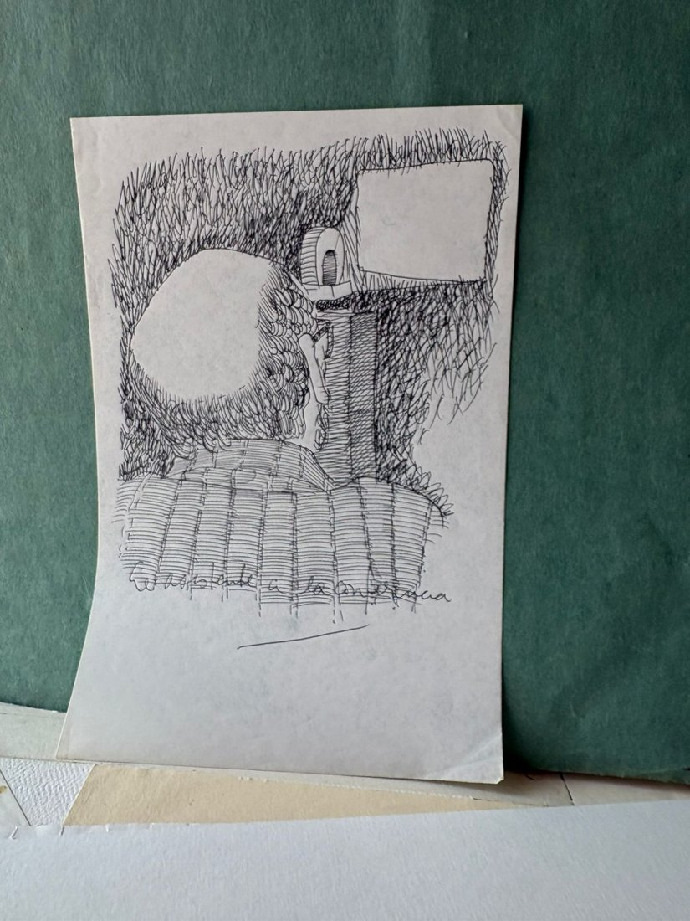 | El asistente a la conferencia  Medium: ink on paper  Year: c. 1980s  Price: $80
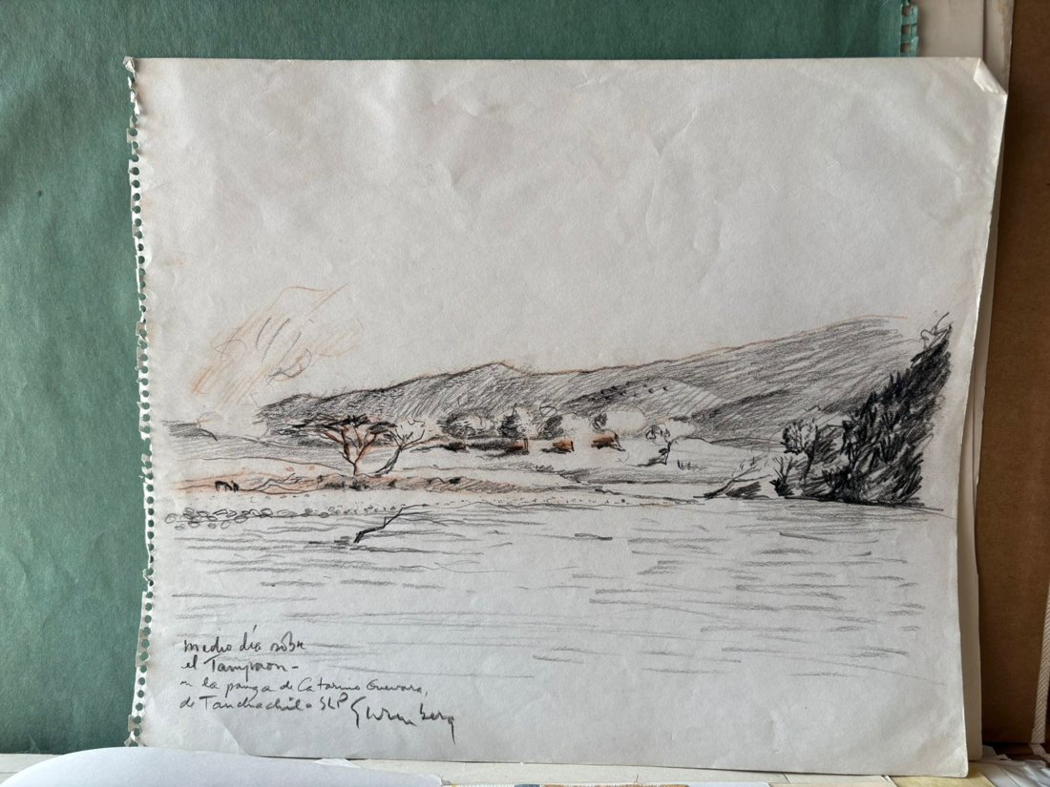 | San Luis Potosí, medio día  Medium: sanguine and charcoal  Year: c. 1990s  Price: $750
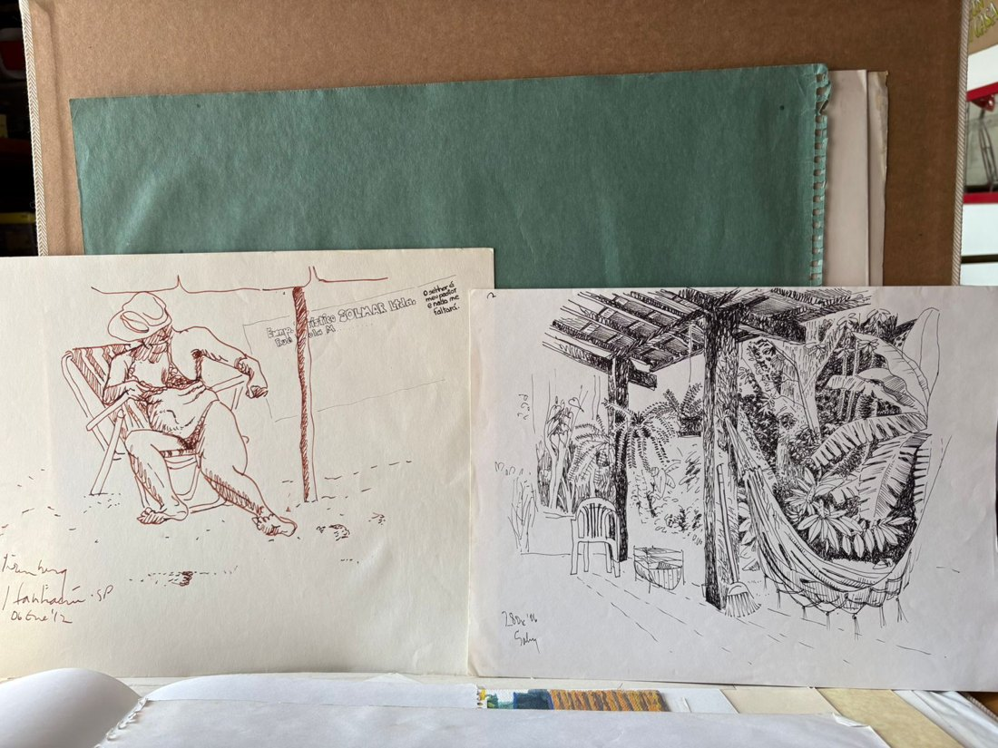 | Itanhaem  Medium: India ink in two colours  Year: 2012  Price: $700
Patio con hamaca
Medium: India ink
Year: 2006
Price: $500
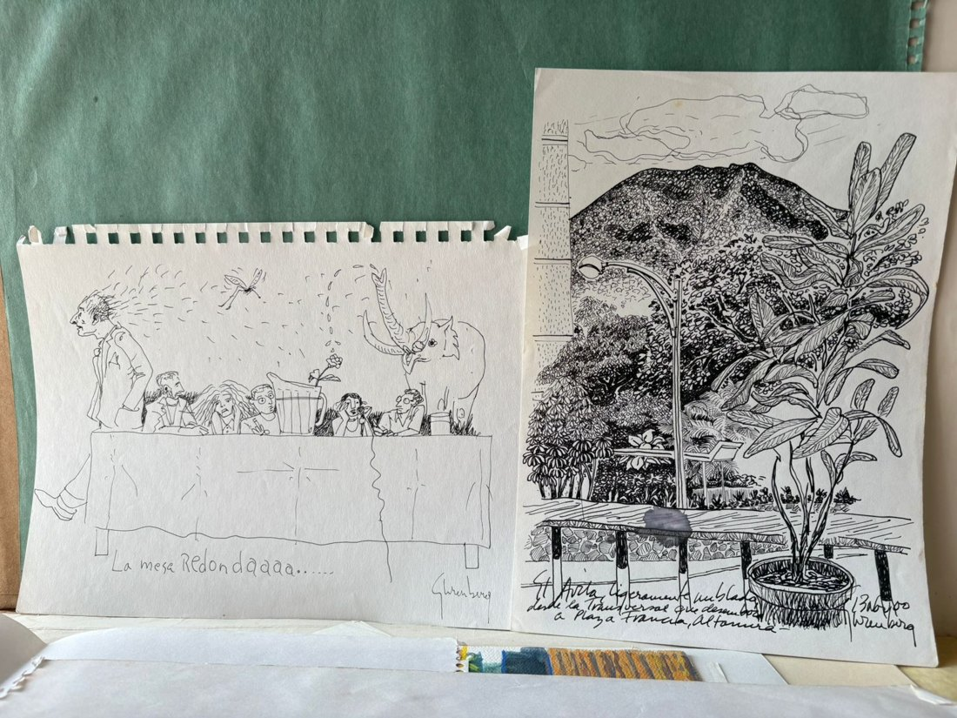 | La mesa redondaaaa  Medium: ink on paper  Year: c. 2000  Price: $300
El Ávila, Caracas.
Medium: ink on paper
Year: 2000
Price: $450
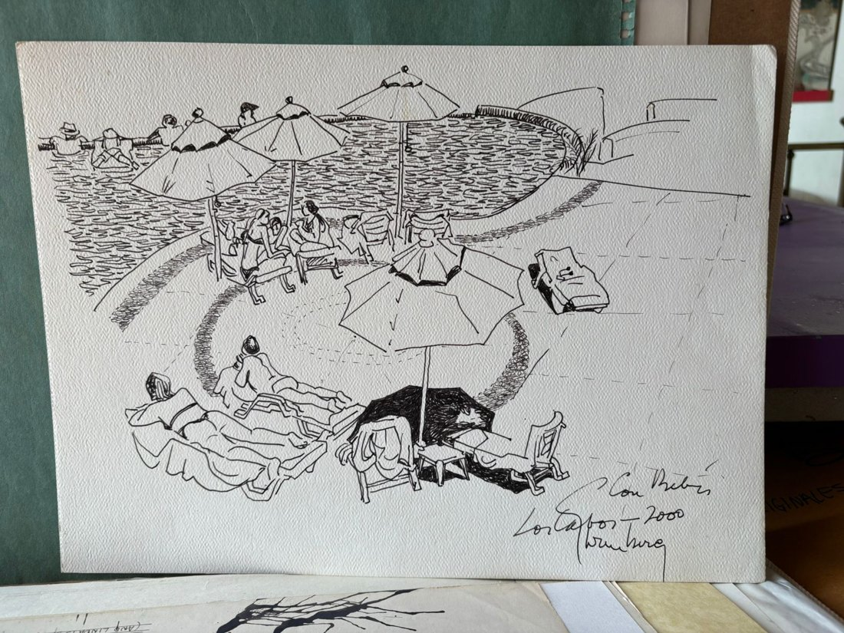 | Los Cabos  Medium: ink on Strathmore paper  Year: 2000  Price: $500
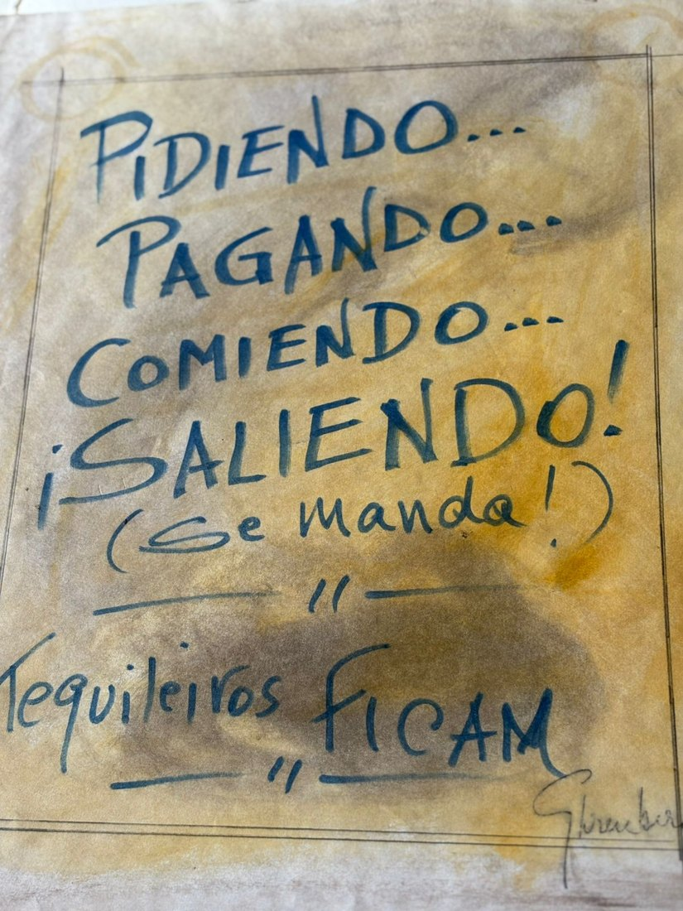 | Pidiendo, Pagando, Comiendo, Saliendo!  Medium: pencil, pastel, varnish and marker  Year: 2010  Price: $500
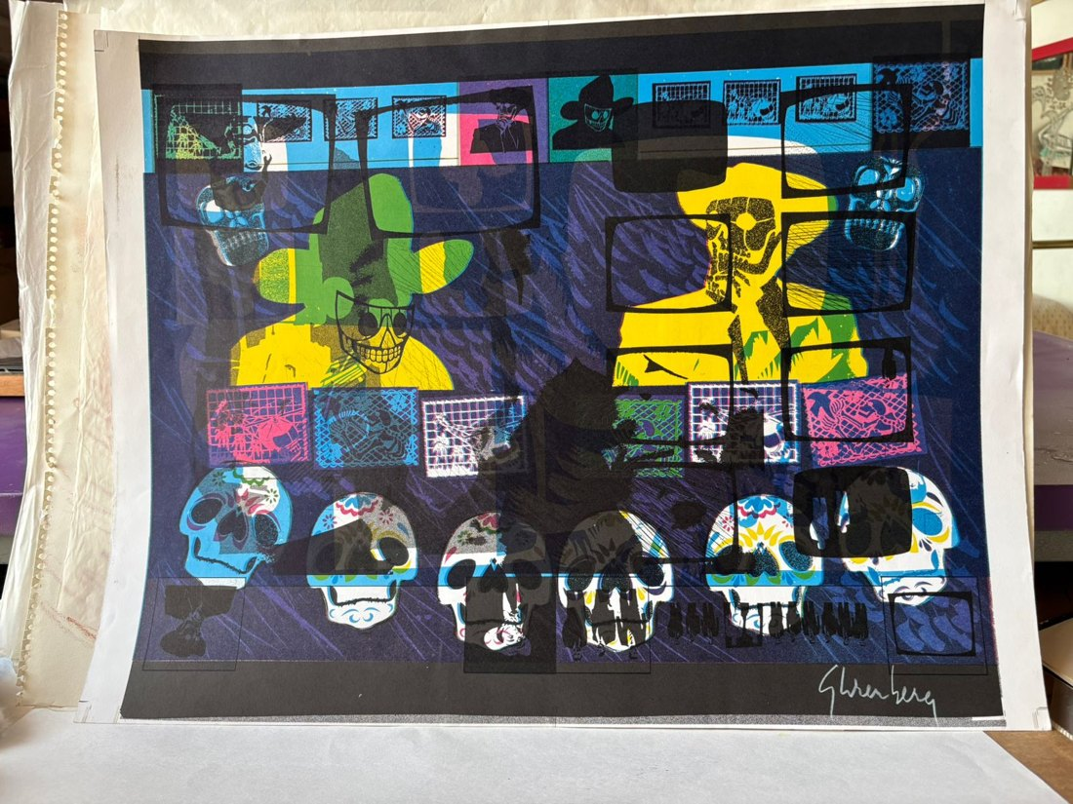 | Codex  Medium: digital print, unique monotype, 5 inks  Year: 1990  Price: $700
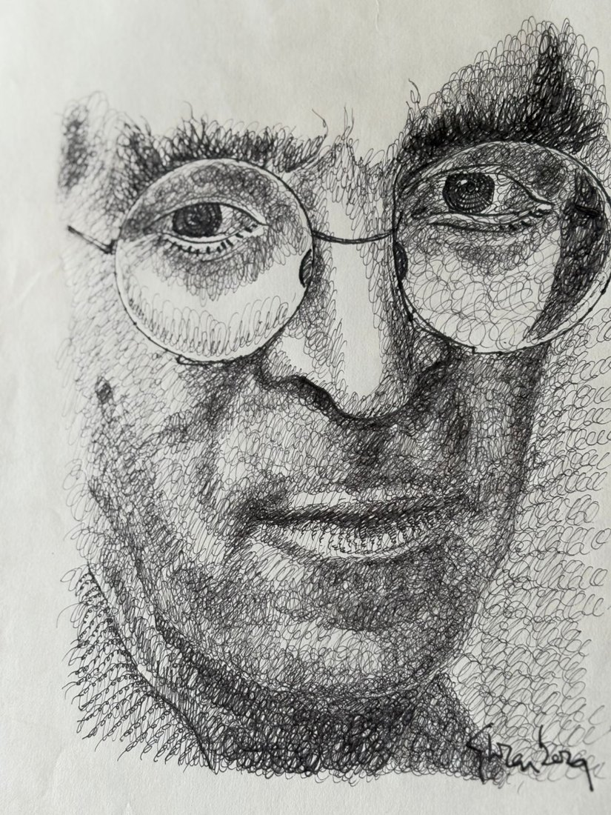 | Retrato de Roberto Bolaño para publicación en la “Folha Ilustrada”, Sao Paulo, Brasil.  Medium: pencil and ink on paper  Year: 2008  Price: $1,500
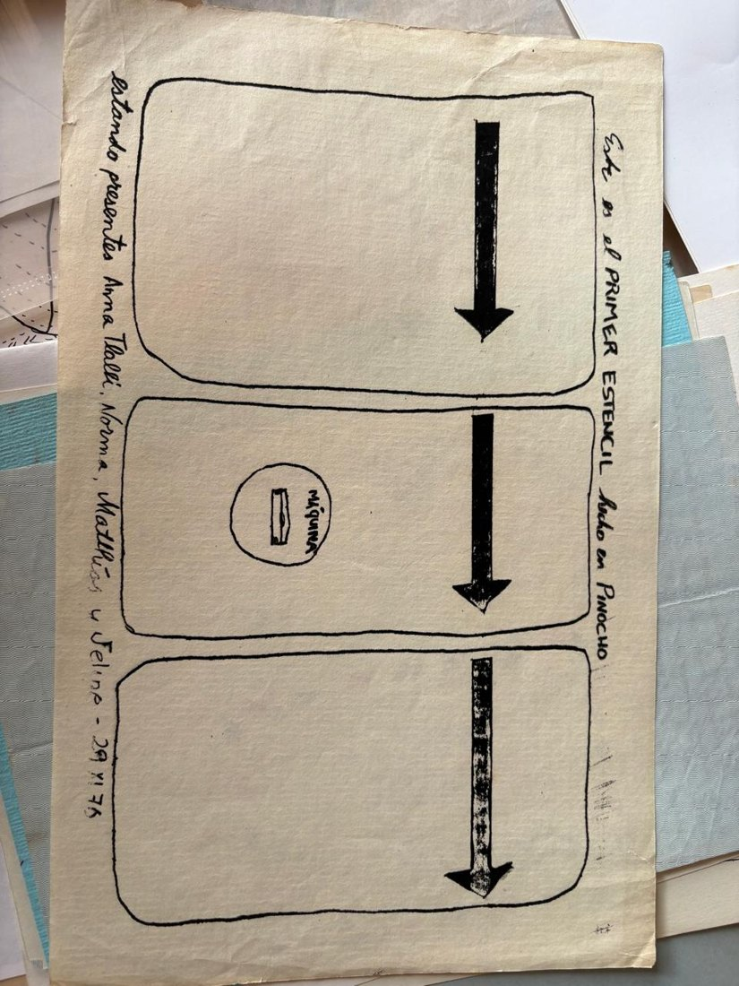 | Esténcil Pinocho  Medium: mimeograph  Year: 1976  Price: $300
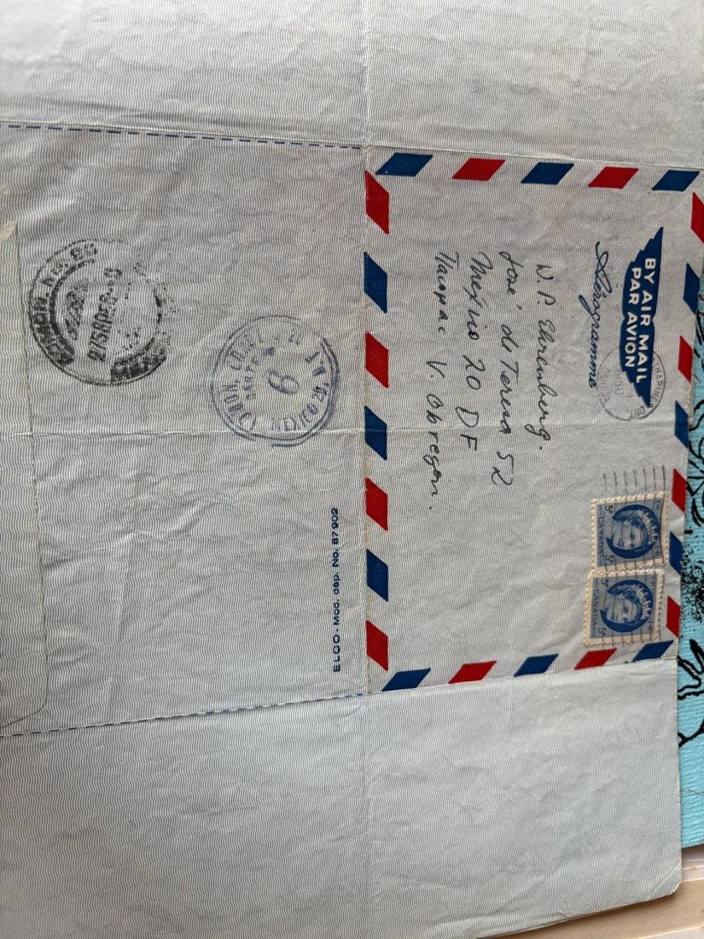 | carta del 27 de noviembre a Walter, su padre, desde Canadá  Medium: pen, envelope and postage stamp  Year: 1956  Price: $100
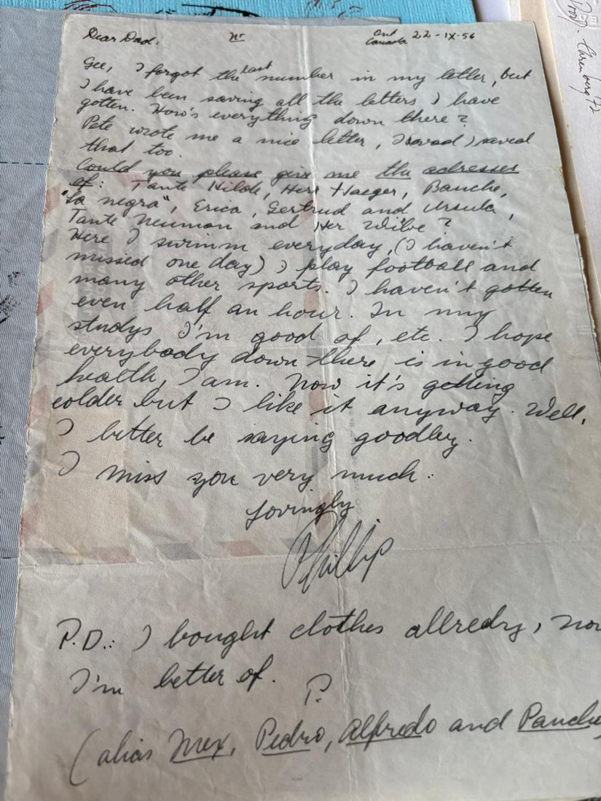 | carta del 22 de noviembre a Walter, su padre, desde Canadá  Medium: pen, envelope and postage stamp  Year: 1956  Price: $100
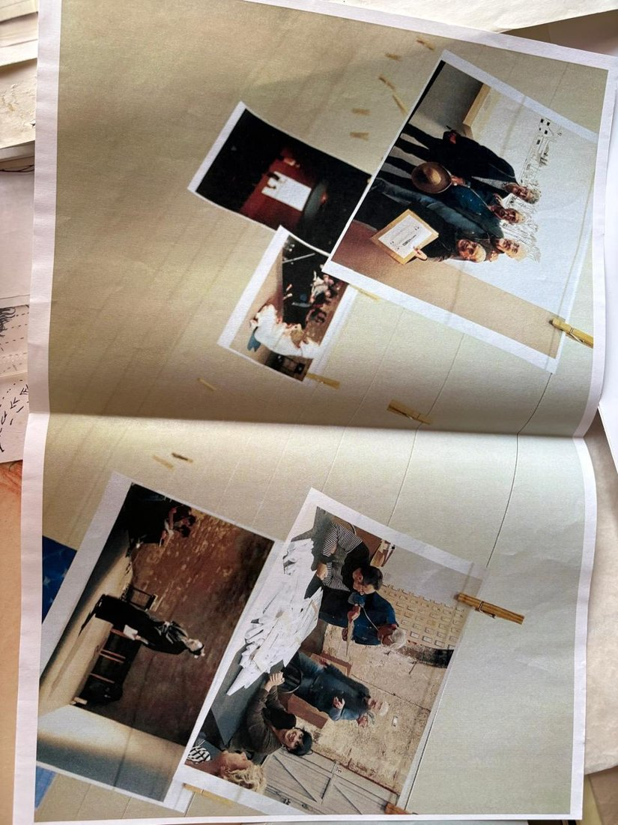 | Collage hecho por Felipe en el reencuentro de los socios de BGP, con motivo del homenaje hermosamente curado por Alice Motard en Burdeos, Francia.  Medium: collage made with digital photographs  Year: 2017  Price: $150
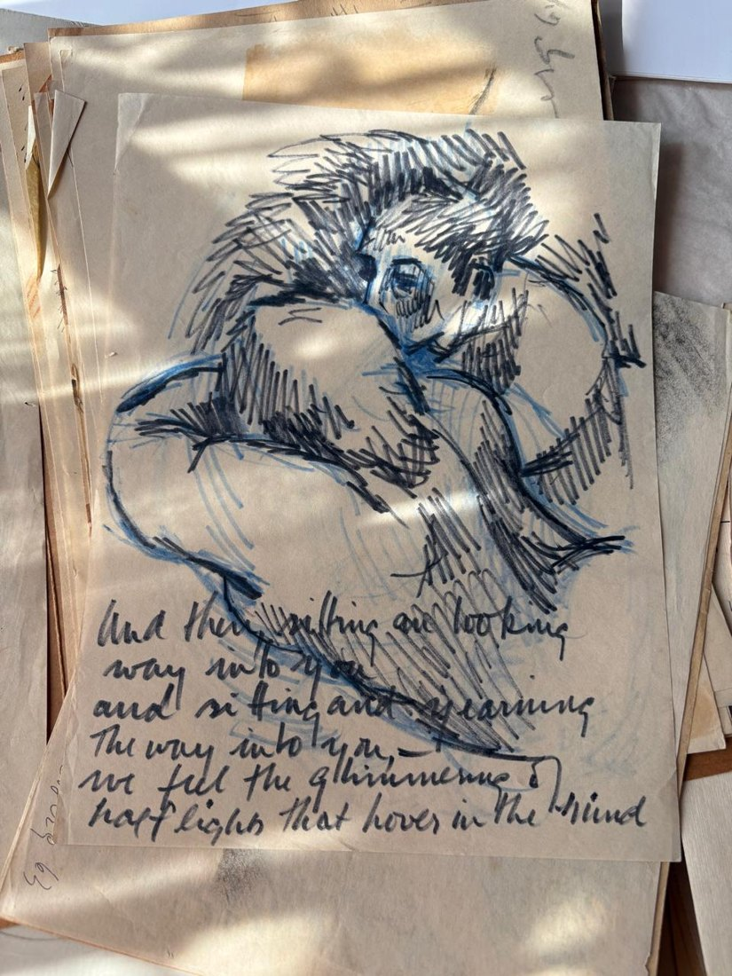 | And then  Medium: marker and coloured pencil on quarto paper  Year: c. 1960s  Price: $900
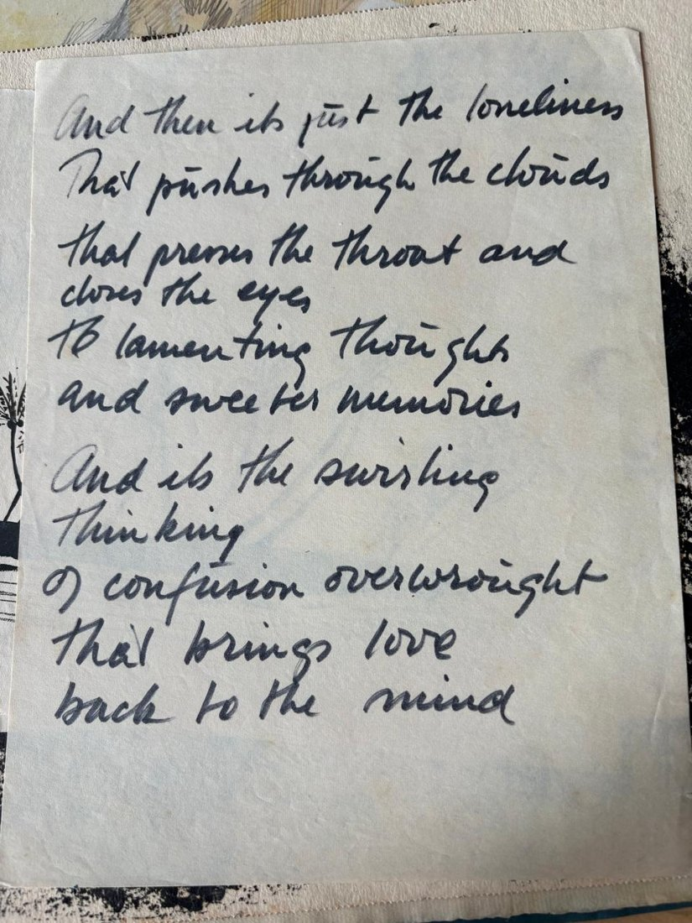 | And then… back to the mind  Medium: marker on quarto paper  Year: c. 1960s  Price: $450
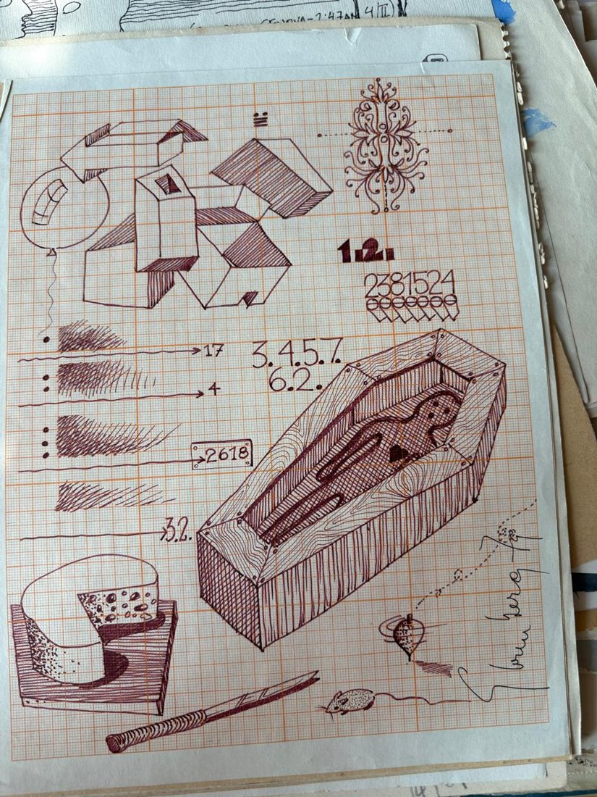 | Ataúd 2381524  Medium: ink on graph paper  Year: 1979  Price: $1,600
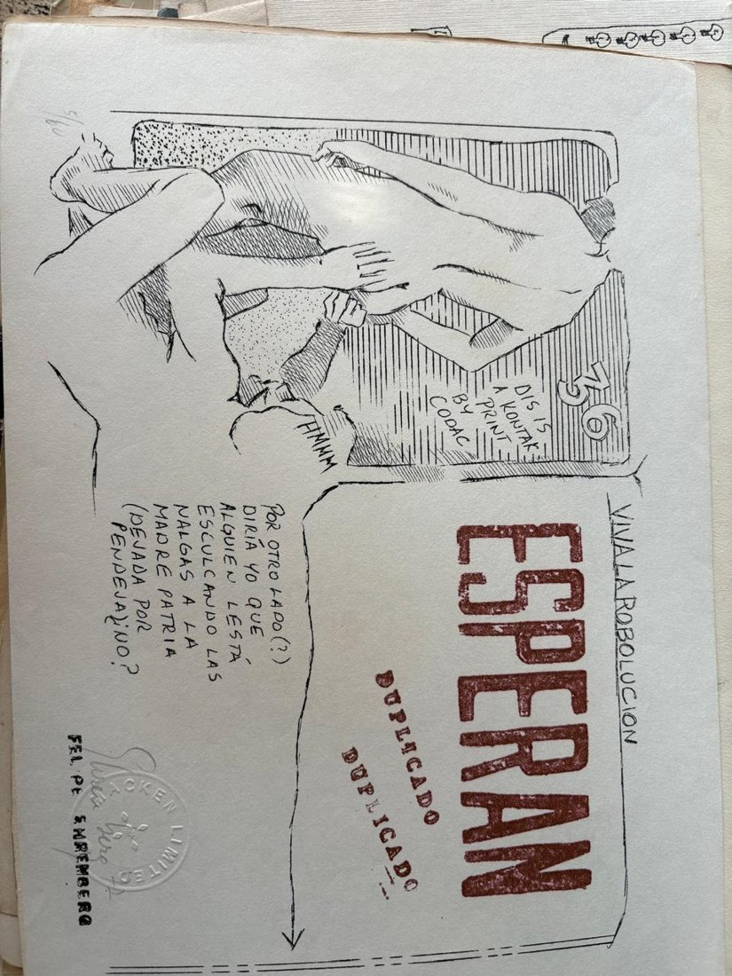 | Viva la Rebolucion  Medium: mimeograph print 5/60, two inks, watermark and rubber stamp  Year: 1972  Price: $320
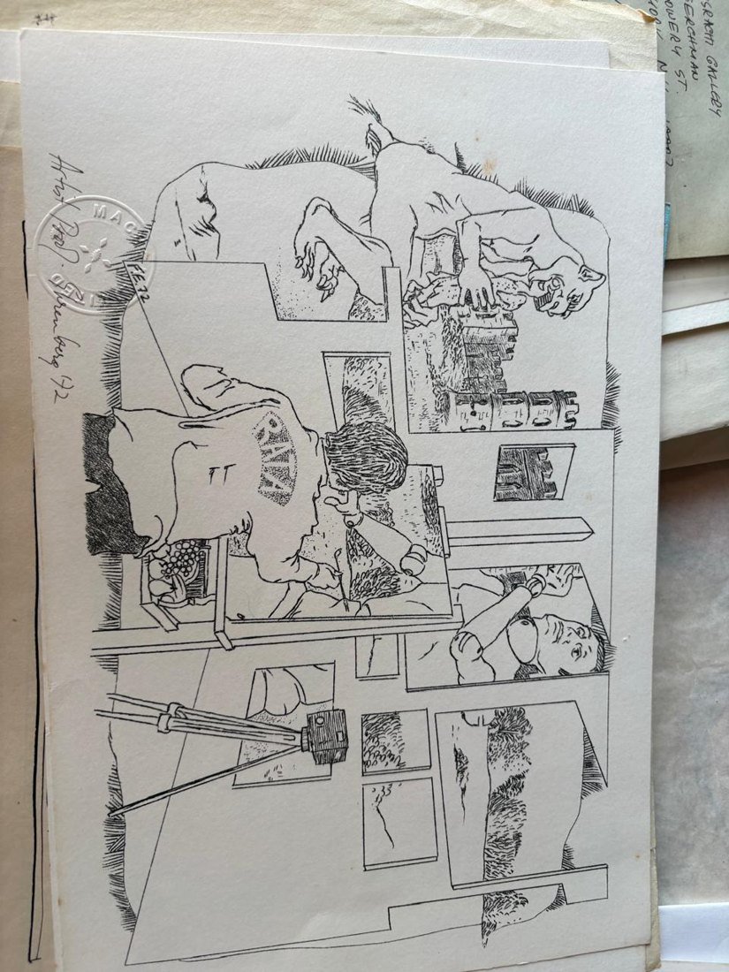 | Rata  Medium: mimeograph with the artist's watermark  Year: 1972  Price: $320
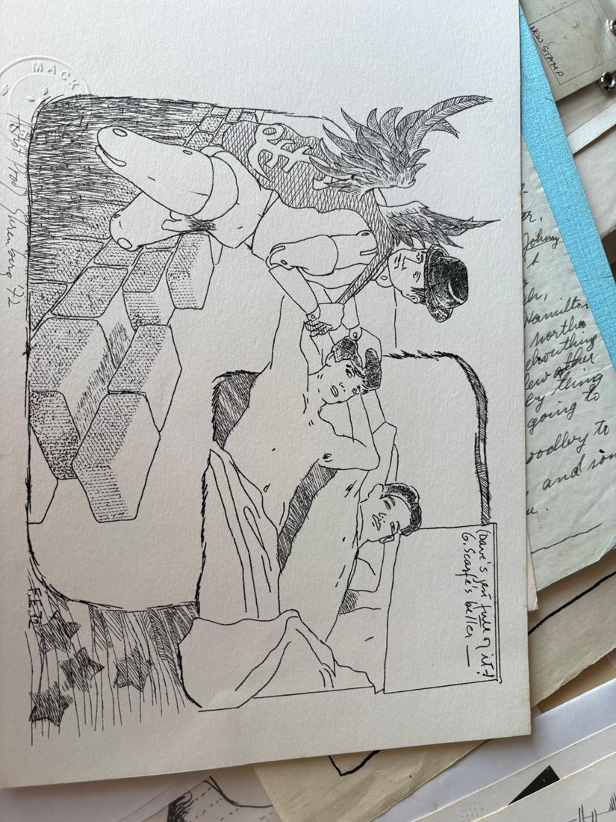 | Dave’s  Medium: mimeograph with the artist's watermark  Year: 1972  Price: $320
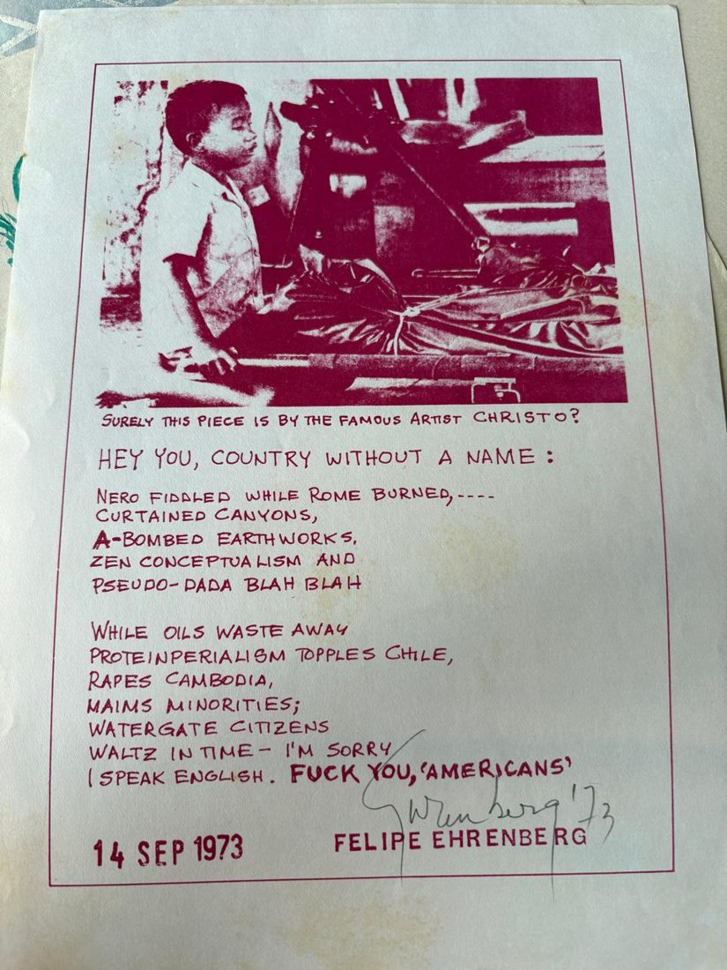 | Hey You, country without a name  Medium: colour mimeograph print  Year: 1973  Price: $250
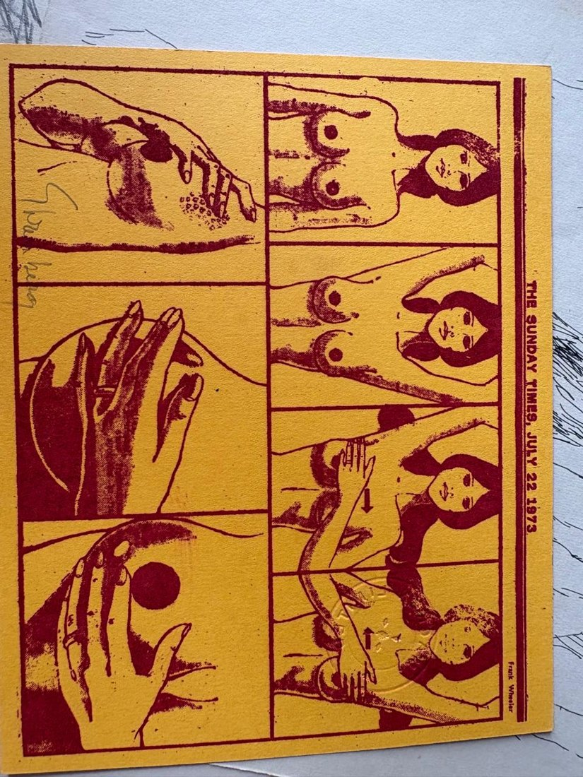 | The Sunday Times  Medium: mimeograph on yellow card in red ink  Year: 1973  Price: $150
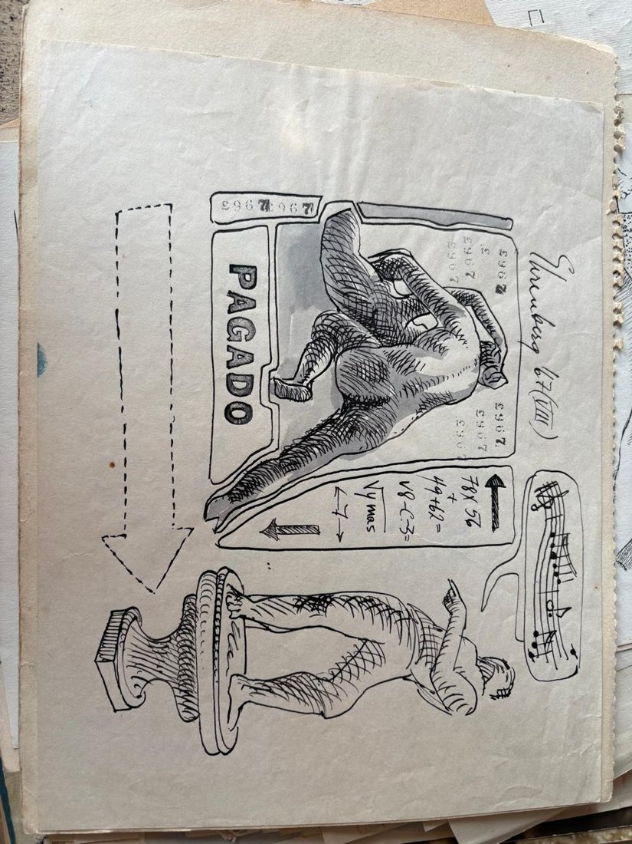 | Pagado con notas musicales  Medium: ink on paper with gouache and rubber stamp  Year: 1967  Price: $600
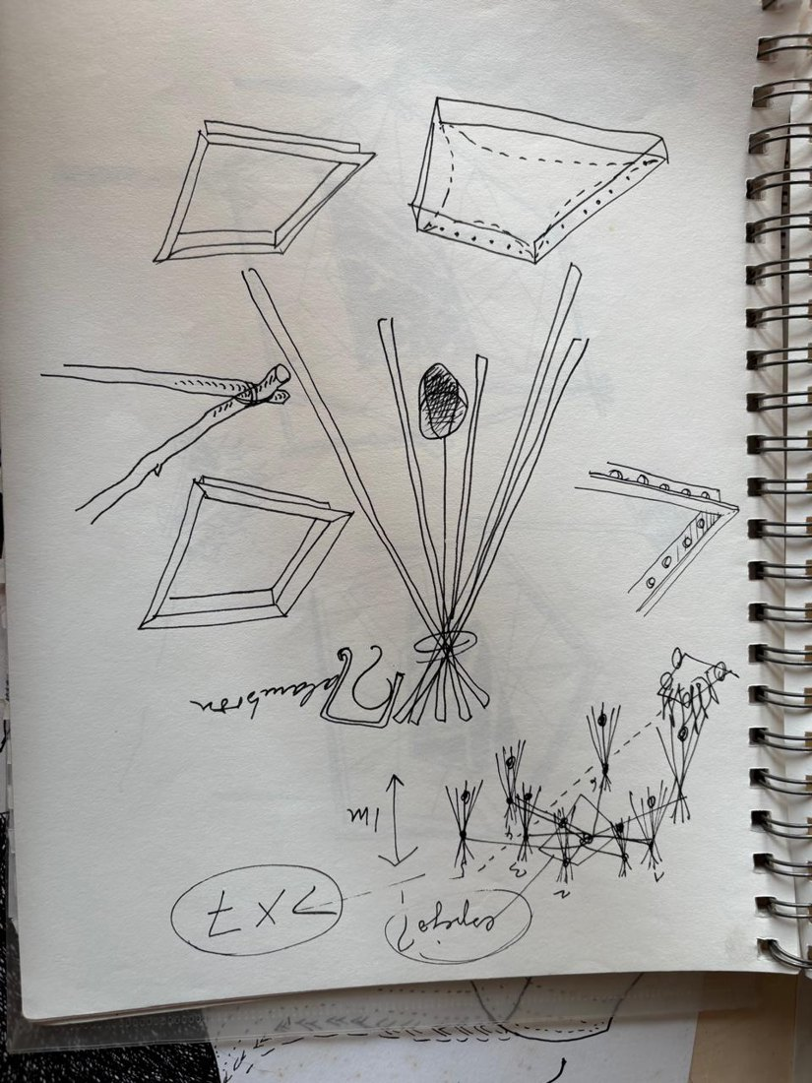 | Boceto corazón estrujado  Medium: ink on Strathmore Sketch paper  Year: 1994  Price: $200
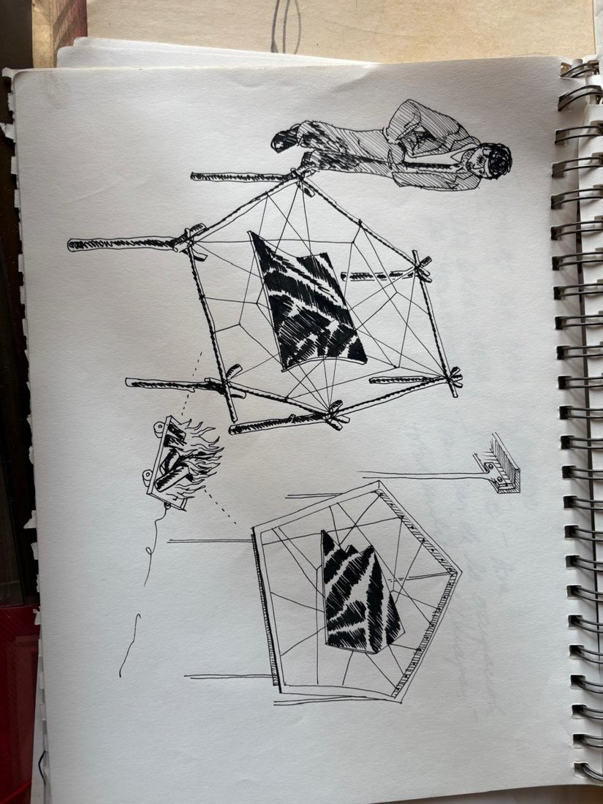 | Hombre y carro de fuego  Medium: ink on Strathmore Sketch paper  Year: 1994  Price: $200
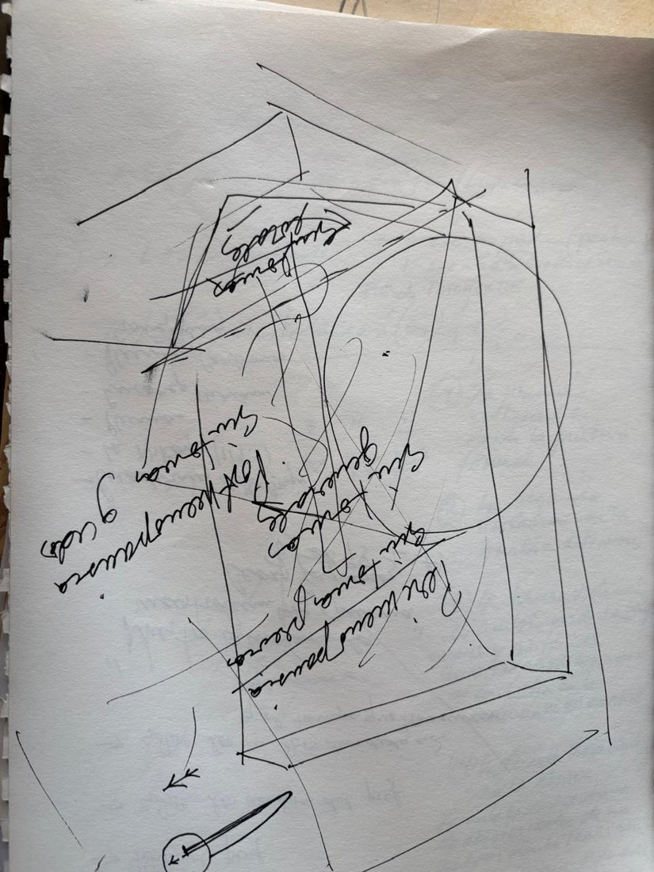 | Perimenopausia  Medium: ink on Strathmore Sketch paper  Year: 1995, notes on both sides  Price: $100
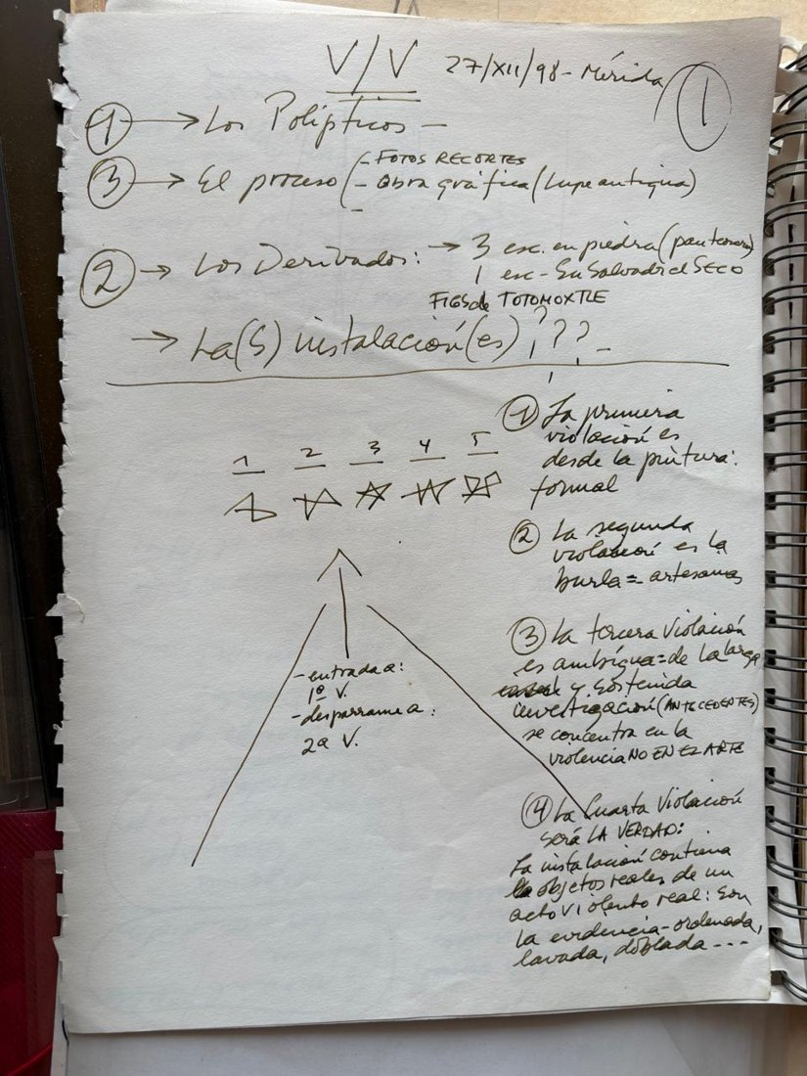 | Las cuatro violaciones  Medium: ink on Strathmore Sketch paper  Year: 1998  Price: $400
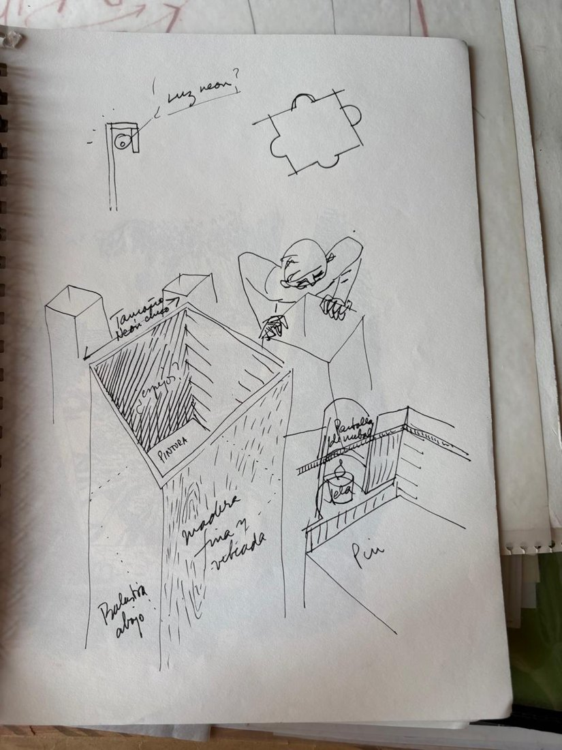 | Apuntes  Medium: ink on Strathmore Sketch paper  Year: 1998  Price: $200
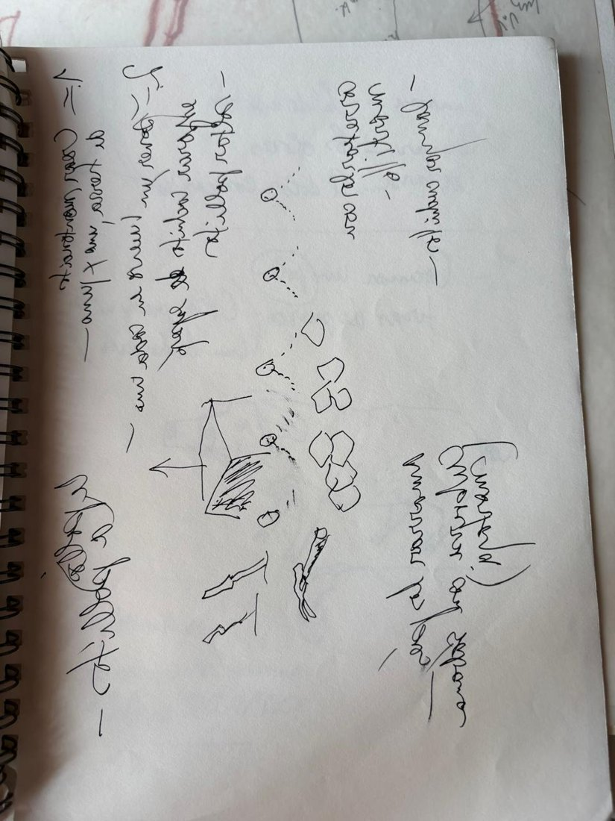 | Proyecto Mortaja  Medium: ink on Strathmore Sketch paper, mirror writing  Year: 1998  Price: $200
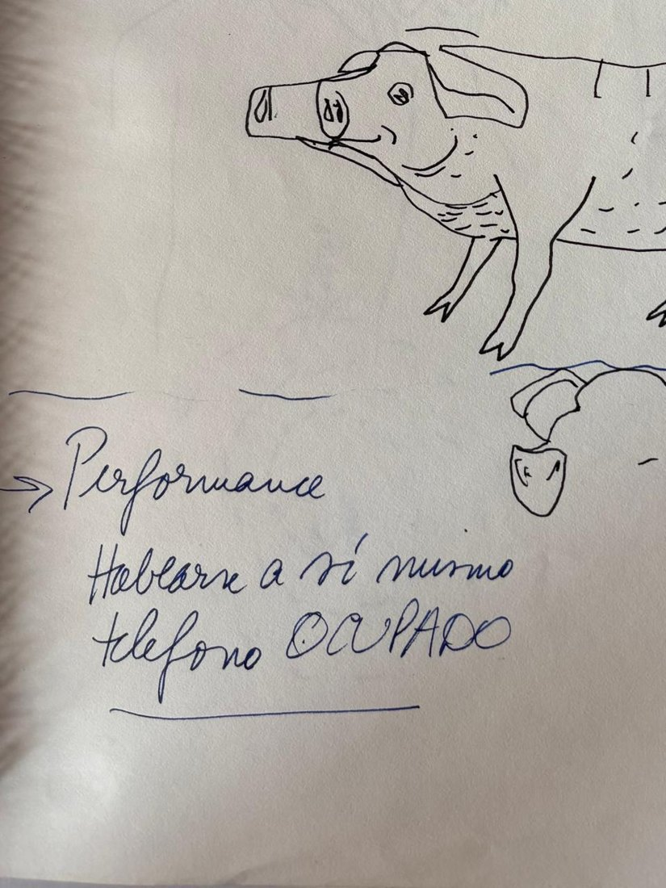 | Teléfono ocupado  Medium: ink on Strathmore Sketch paper, mirror writing  Year: 1998  Price: $200
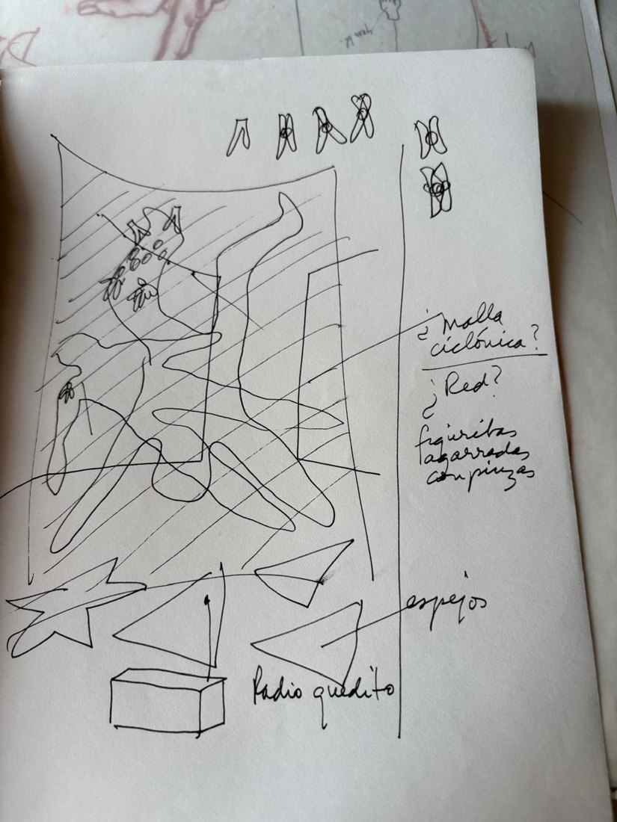 | Proyecto, Hombre que cae  Medium: ink on Strathmore Sketch paper, mirror writing  Year: 2001  Price: $200
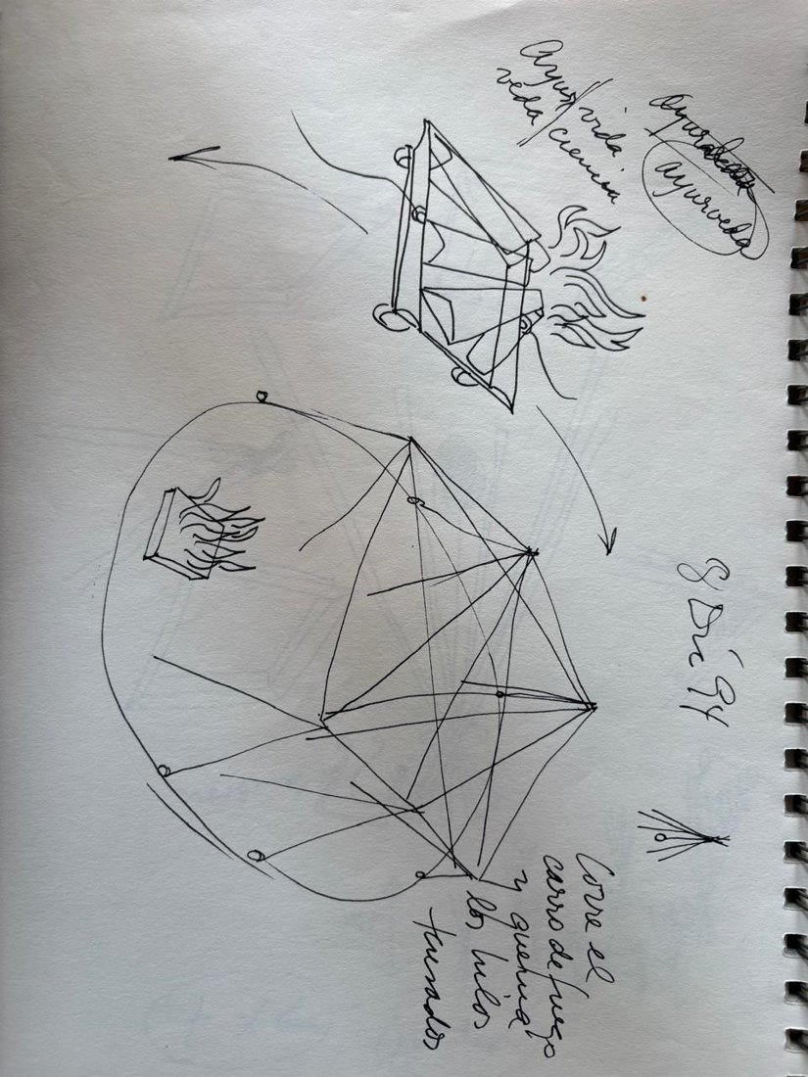 | Carro de fuego  Medium: ink on Strathmore Sketch paper, written to be read in a mirror  Year: 1994  Price: $200
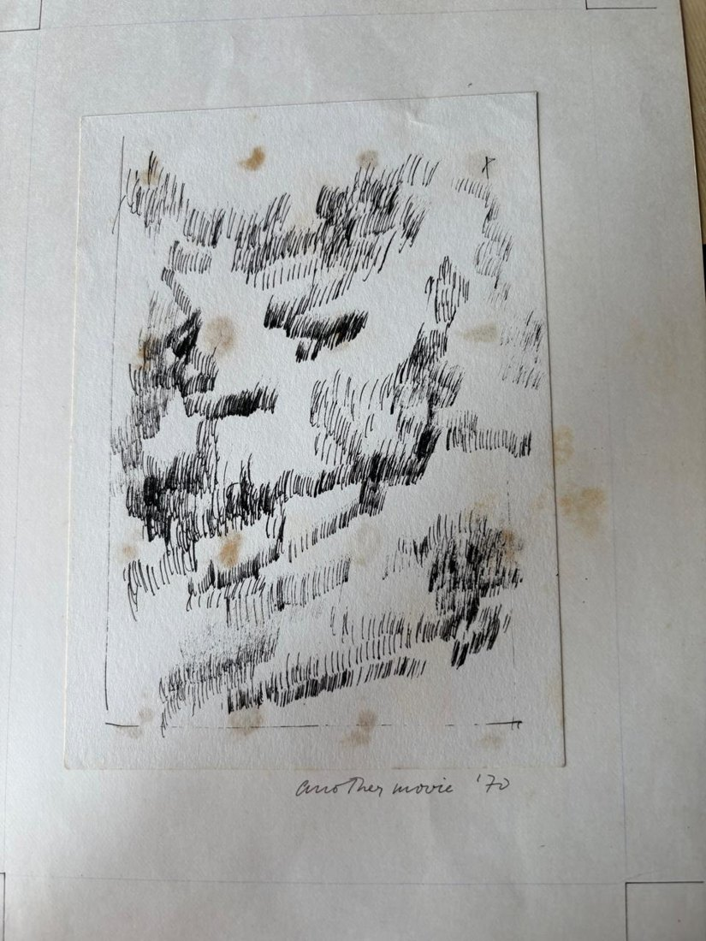 | Another movie  Medium: pen on paper  Year: 1970  Price: $1,000
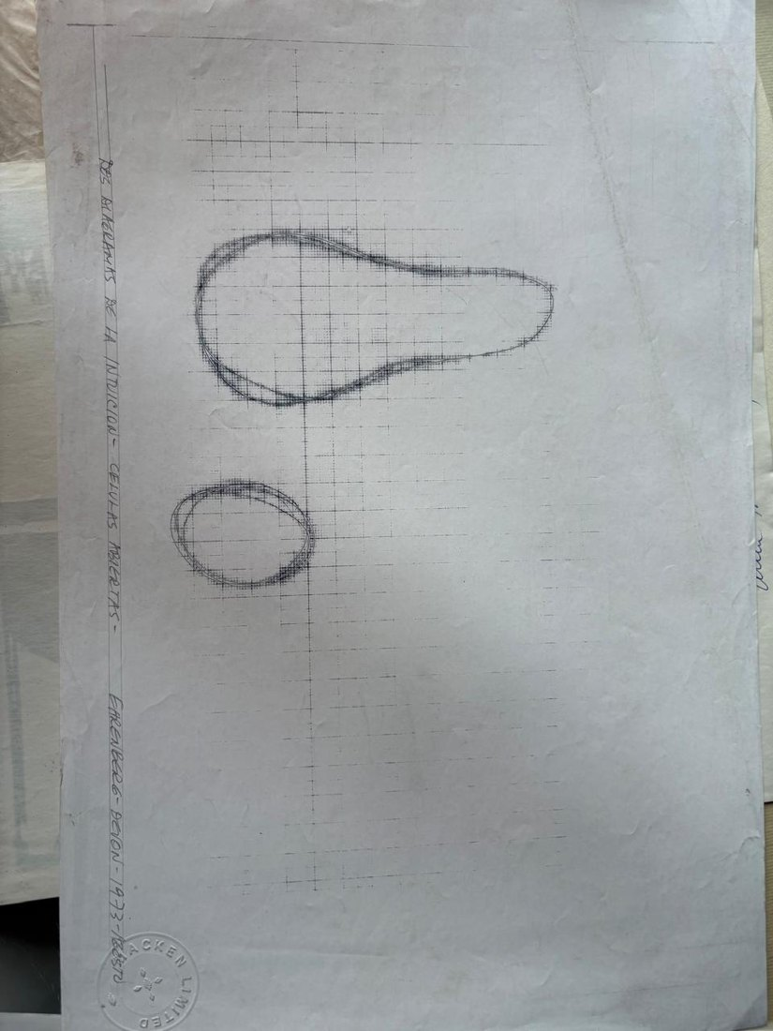 | Dos diagramas de la intuición  Medium: mimeograph, pencil and watermark  Year: 1973  Price: $320
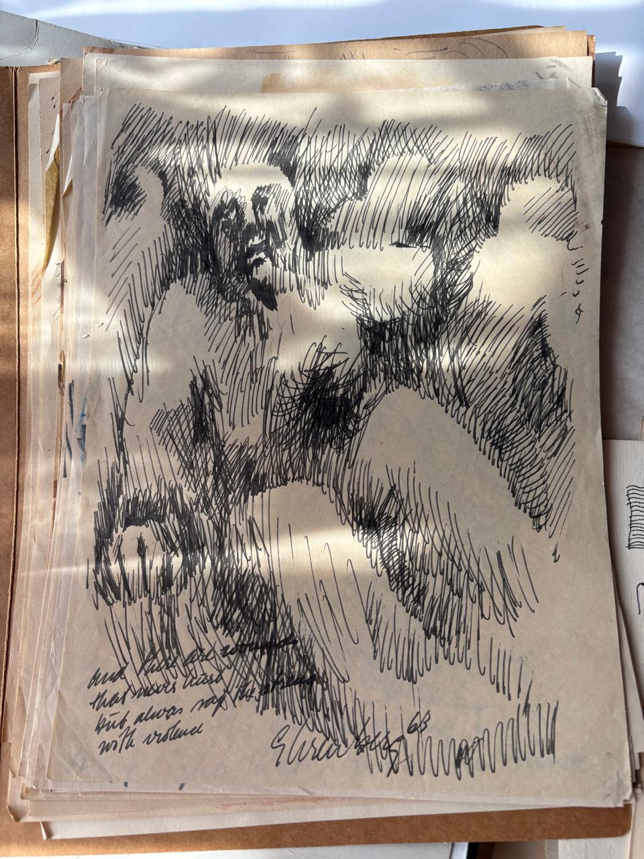 | And there…with violence  Medium: ink on paper  Year: 1963  Price: $900
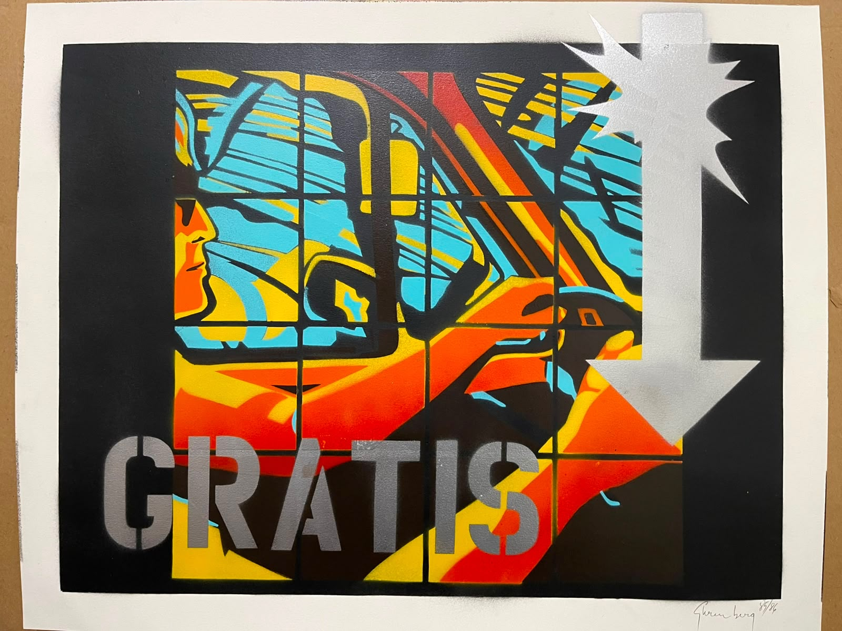 | Gratis  Medium: hand-cut stencils and colour spray paint on paper  Year: 1985-1986  Price: €4,500

